|  |  |  |  |  |  |
| --- | --- | --- | --- | --- | --- |
| **Declaration** |  | | | | |
| Questions in this exercise are intentionally complex and could be convoluted or confusing. This is by design and to simulate real life situations where customers seldom give crystal clear requirements and ask unambiguous questions. | | | | | |
|
|
| I have read the above statement and agree to these conditions | | | | | |
| I AGREE | Pratibha Dixit | | | | |
| <Enter your name above this line to indicate that you are in agreement> | | | | |
|  |  |  |  |  |  |

**Step 3 : Creation of database and application servers**

|  |  |  |  |  |
| --- | --- | --- | --- | --- |
| Step number | a |  |  |  |
| Step name | Creation of application server |  |  |  |
| Instructions | 1) Navigate to EC2 using the Services button at the top of the screen  2) Select Instances at the left side of the screen  3) Click on Launch Instance  - Select the AMI Amazon 2 Linux  - Select the instance type t2.micro  - Select Network as "Project 1 VPC" and subnet as "Public Subnet"  - For the security group, open the ports 80,443, 22 and 8065 for source set to "Anywhere"  4) Launch the instance after creating a new pem file and downloading it | | | |
| Expected screenshots | 1. AMI used 2. Instance configuration screen 3. Security group rules 4. Instance after creation |  |  |  |

**<Insert screenshot a(1) here>**

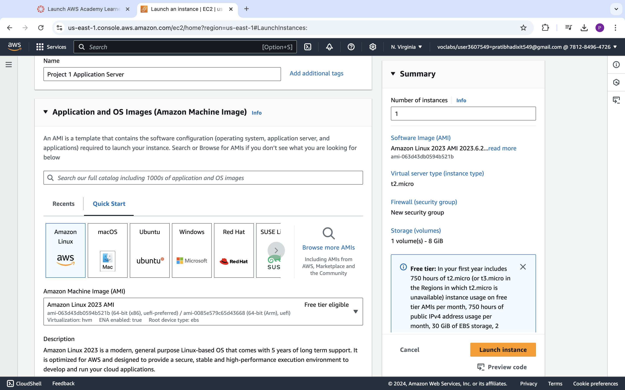

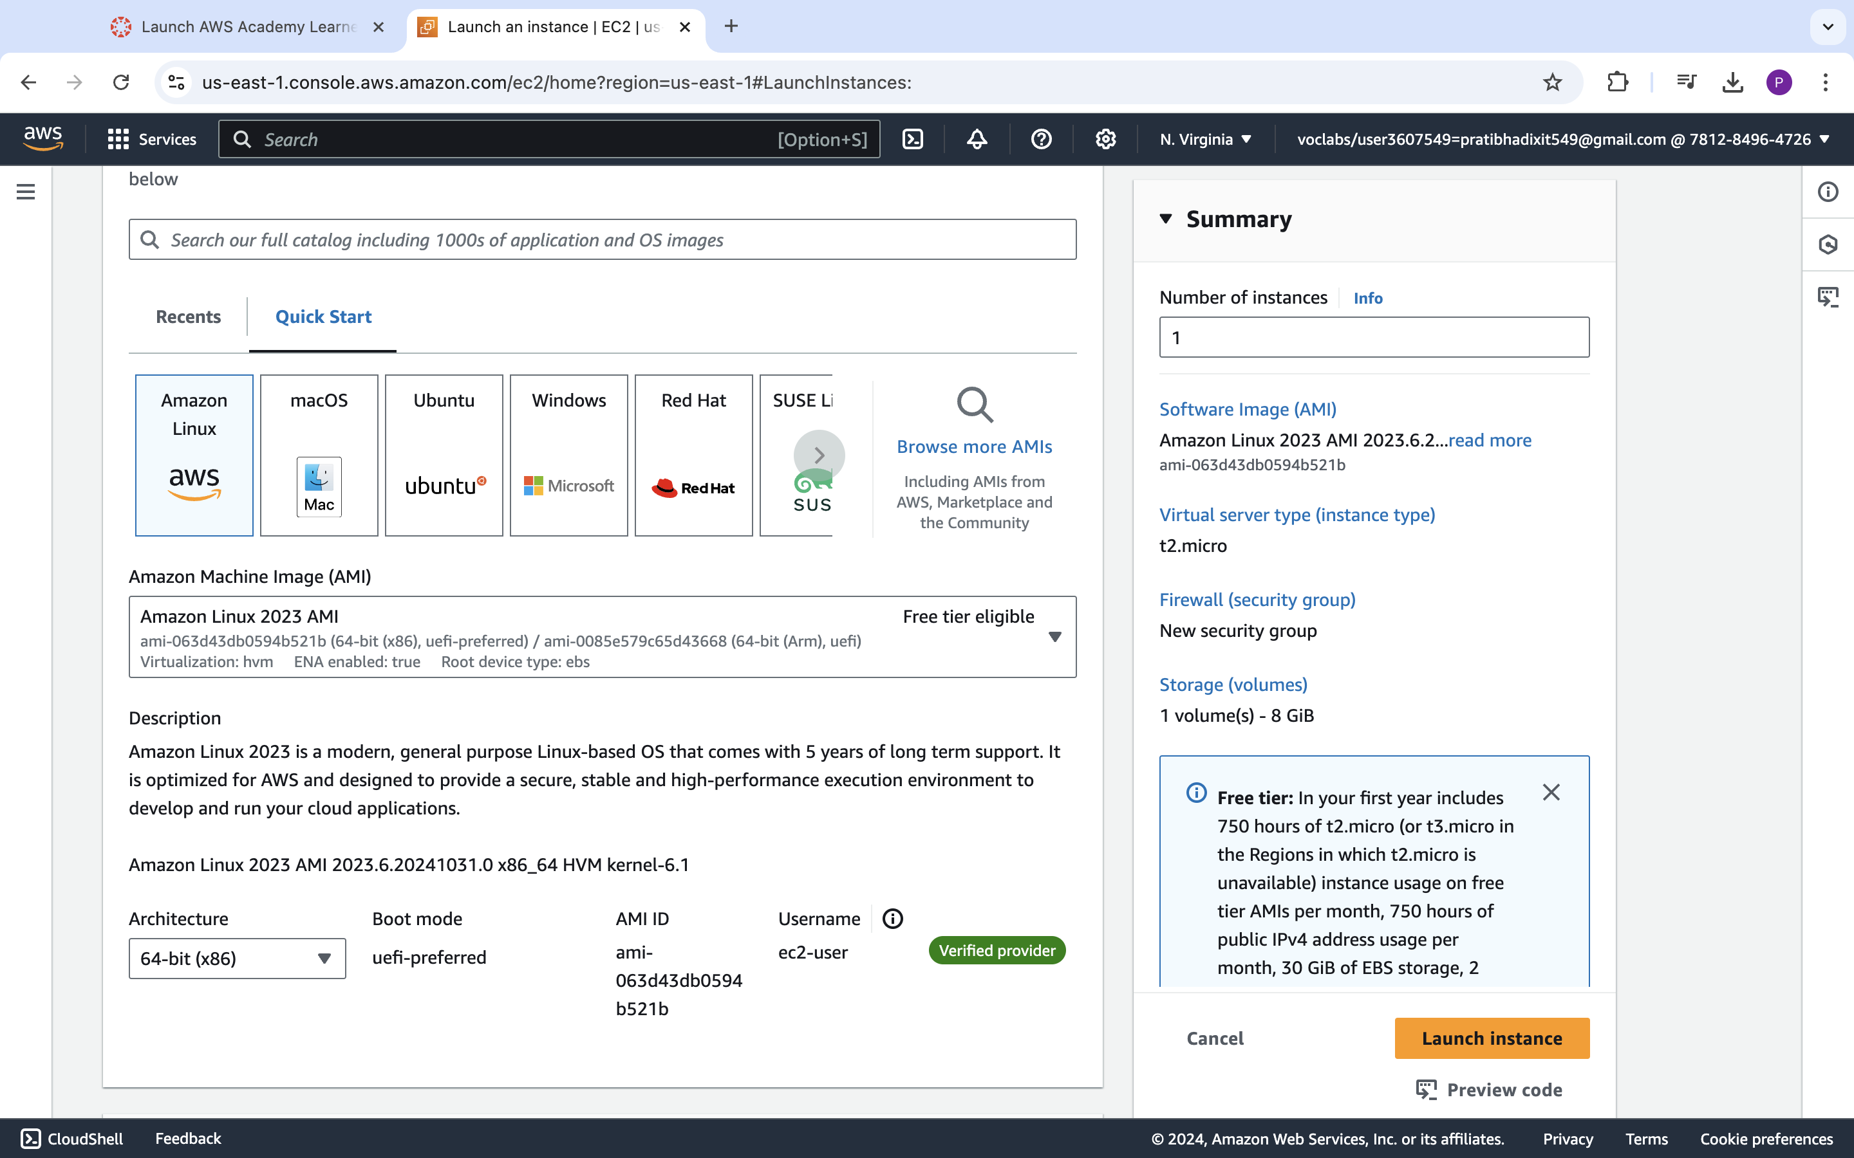

**<Insert screenshot a(2) here>**

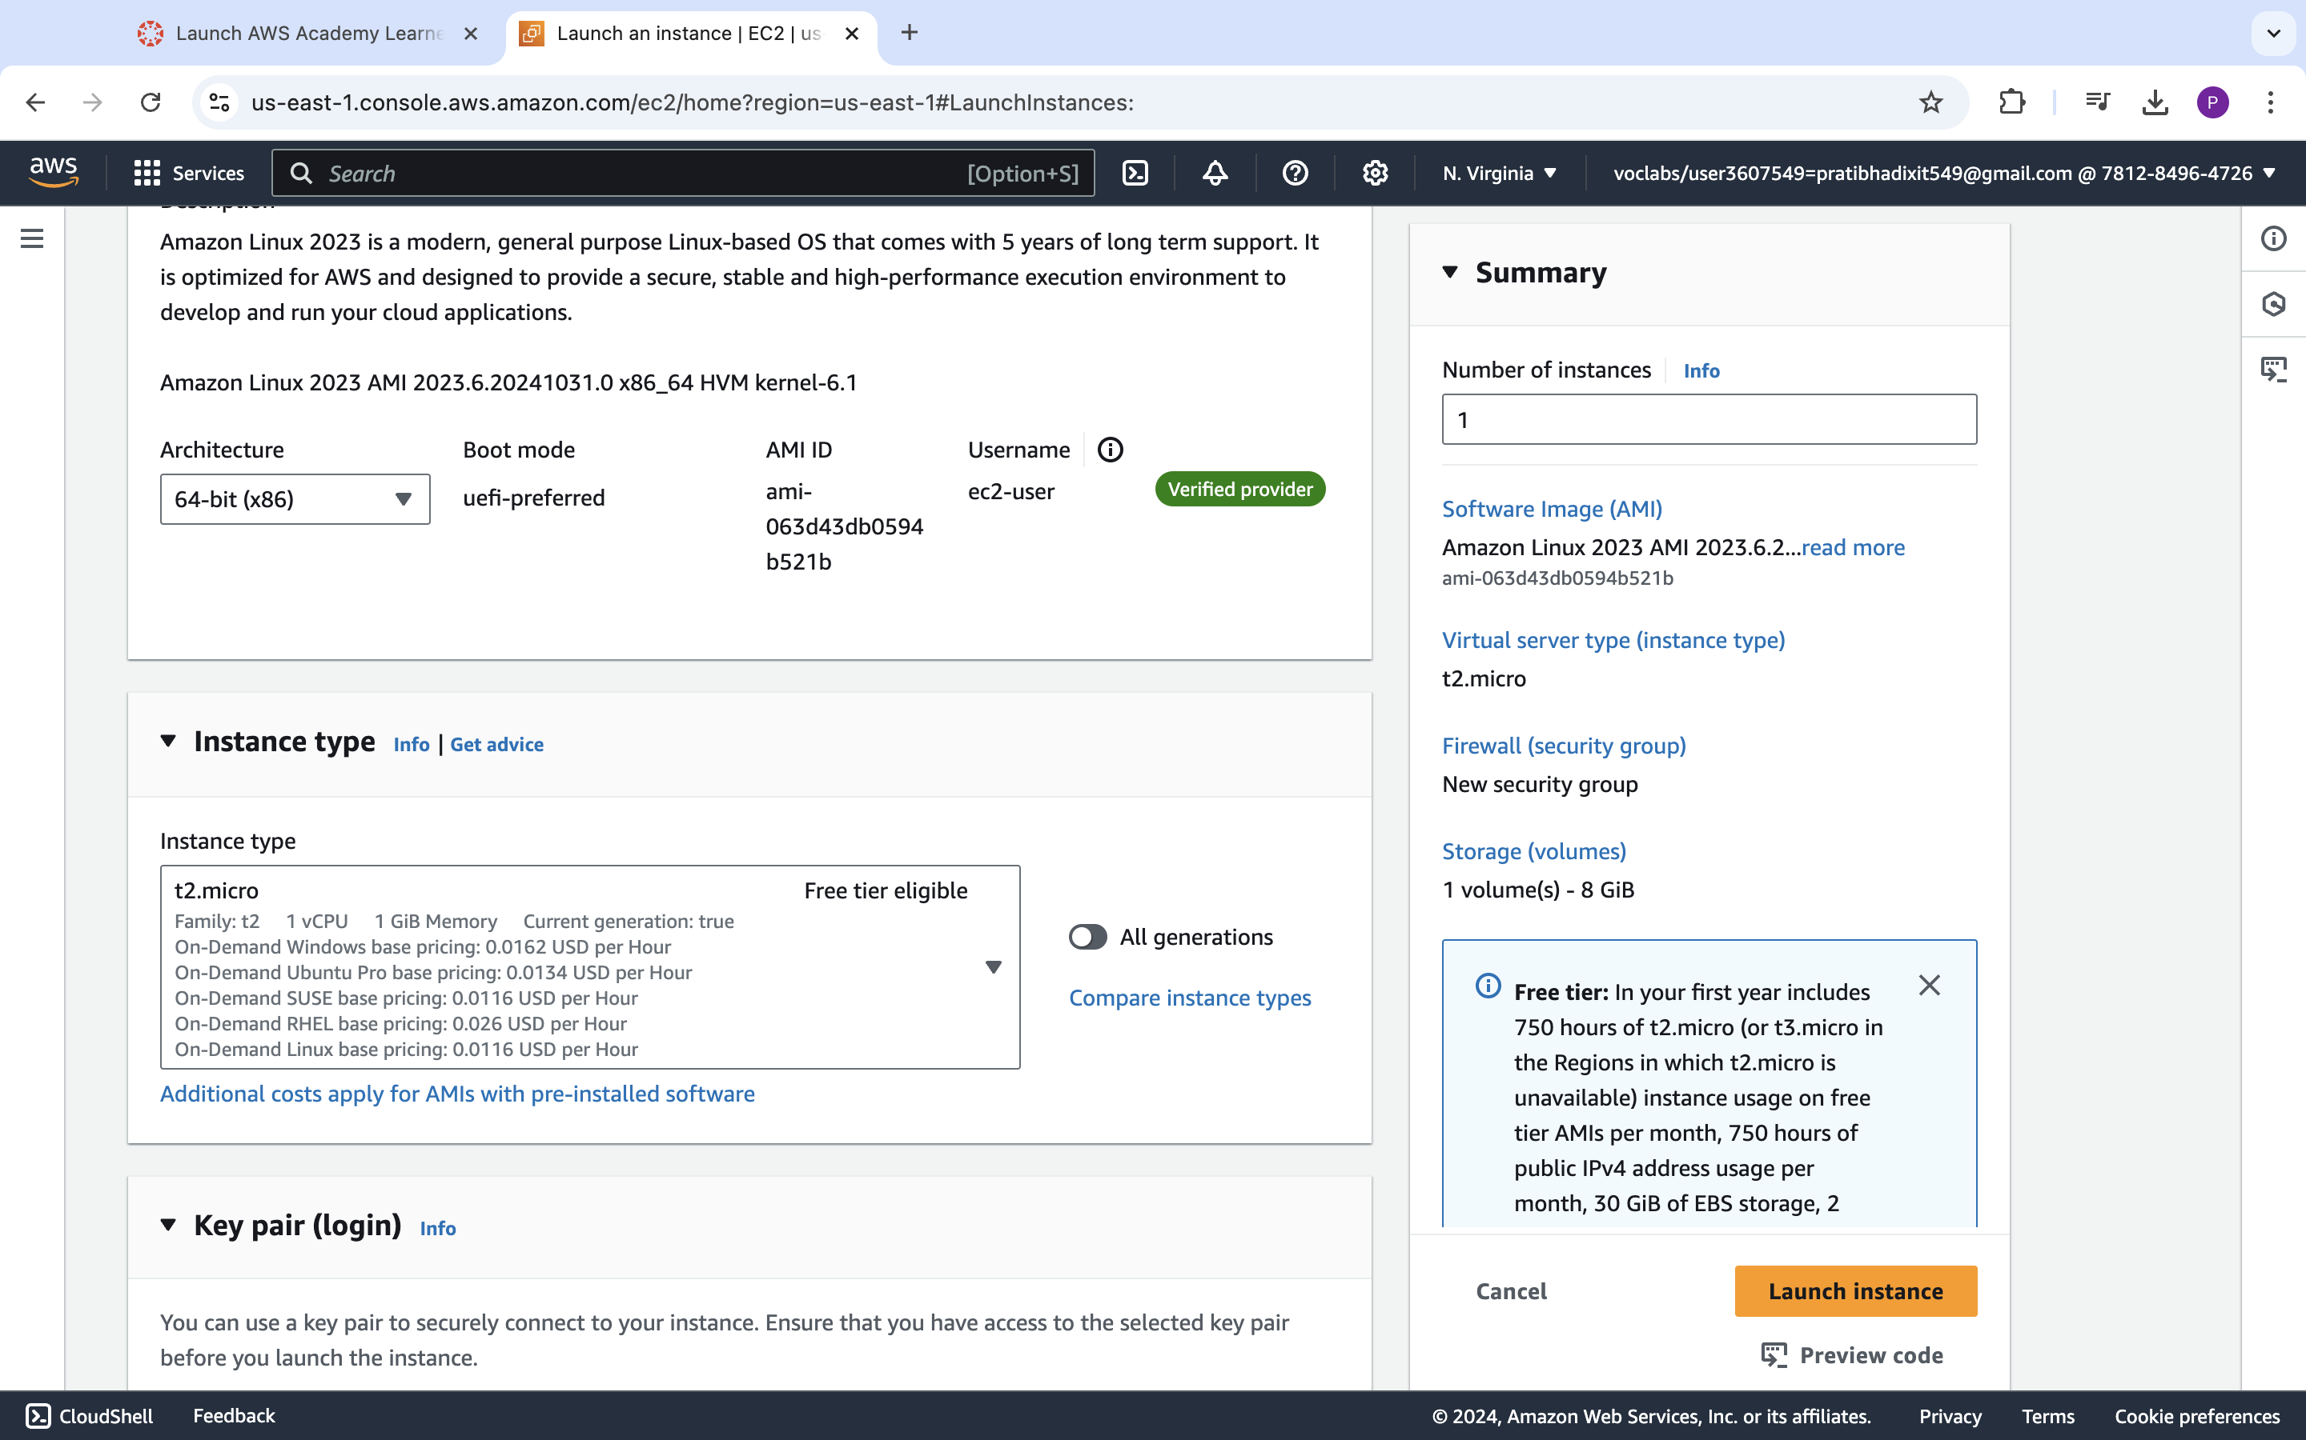

**<Insert screenshot a(3) here>**

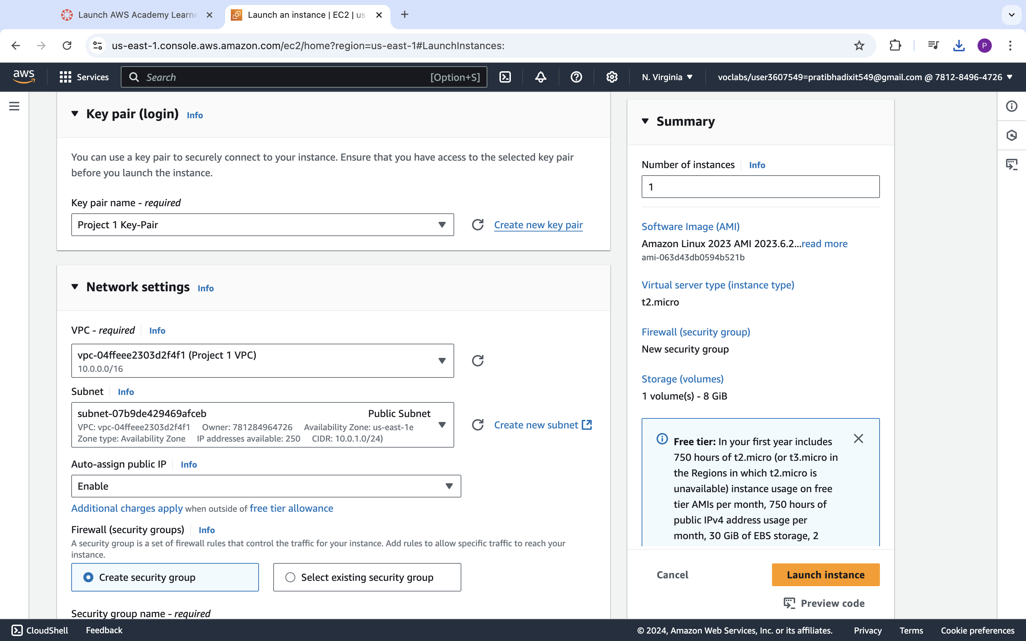

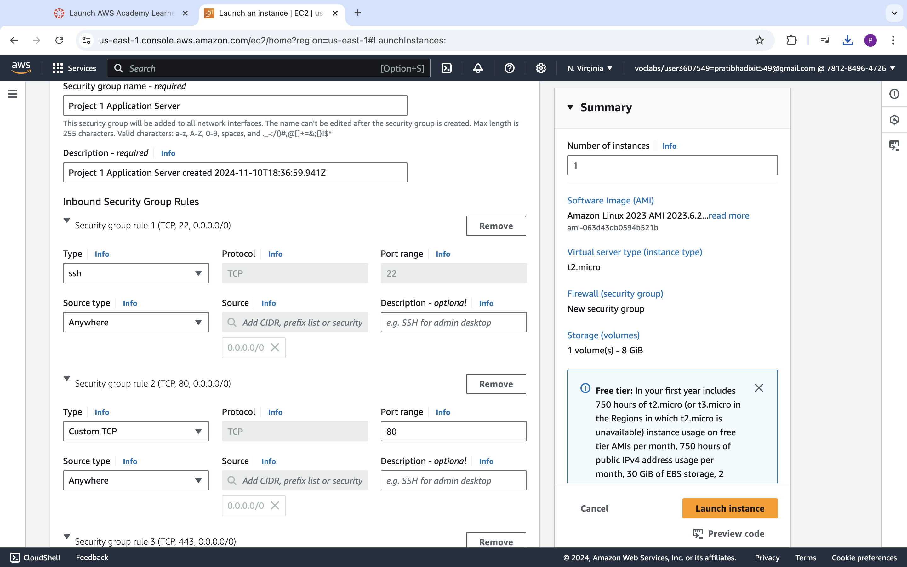

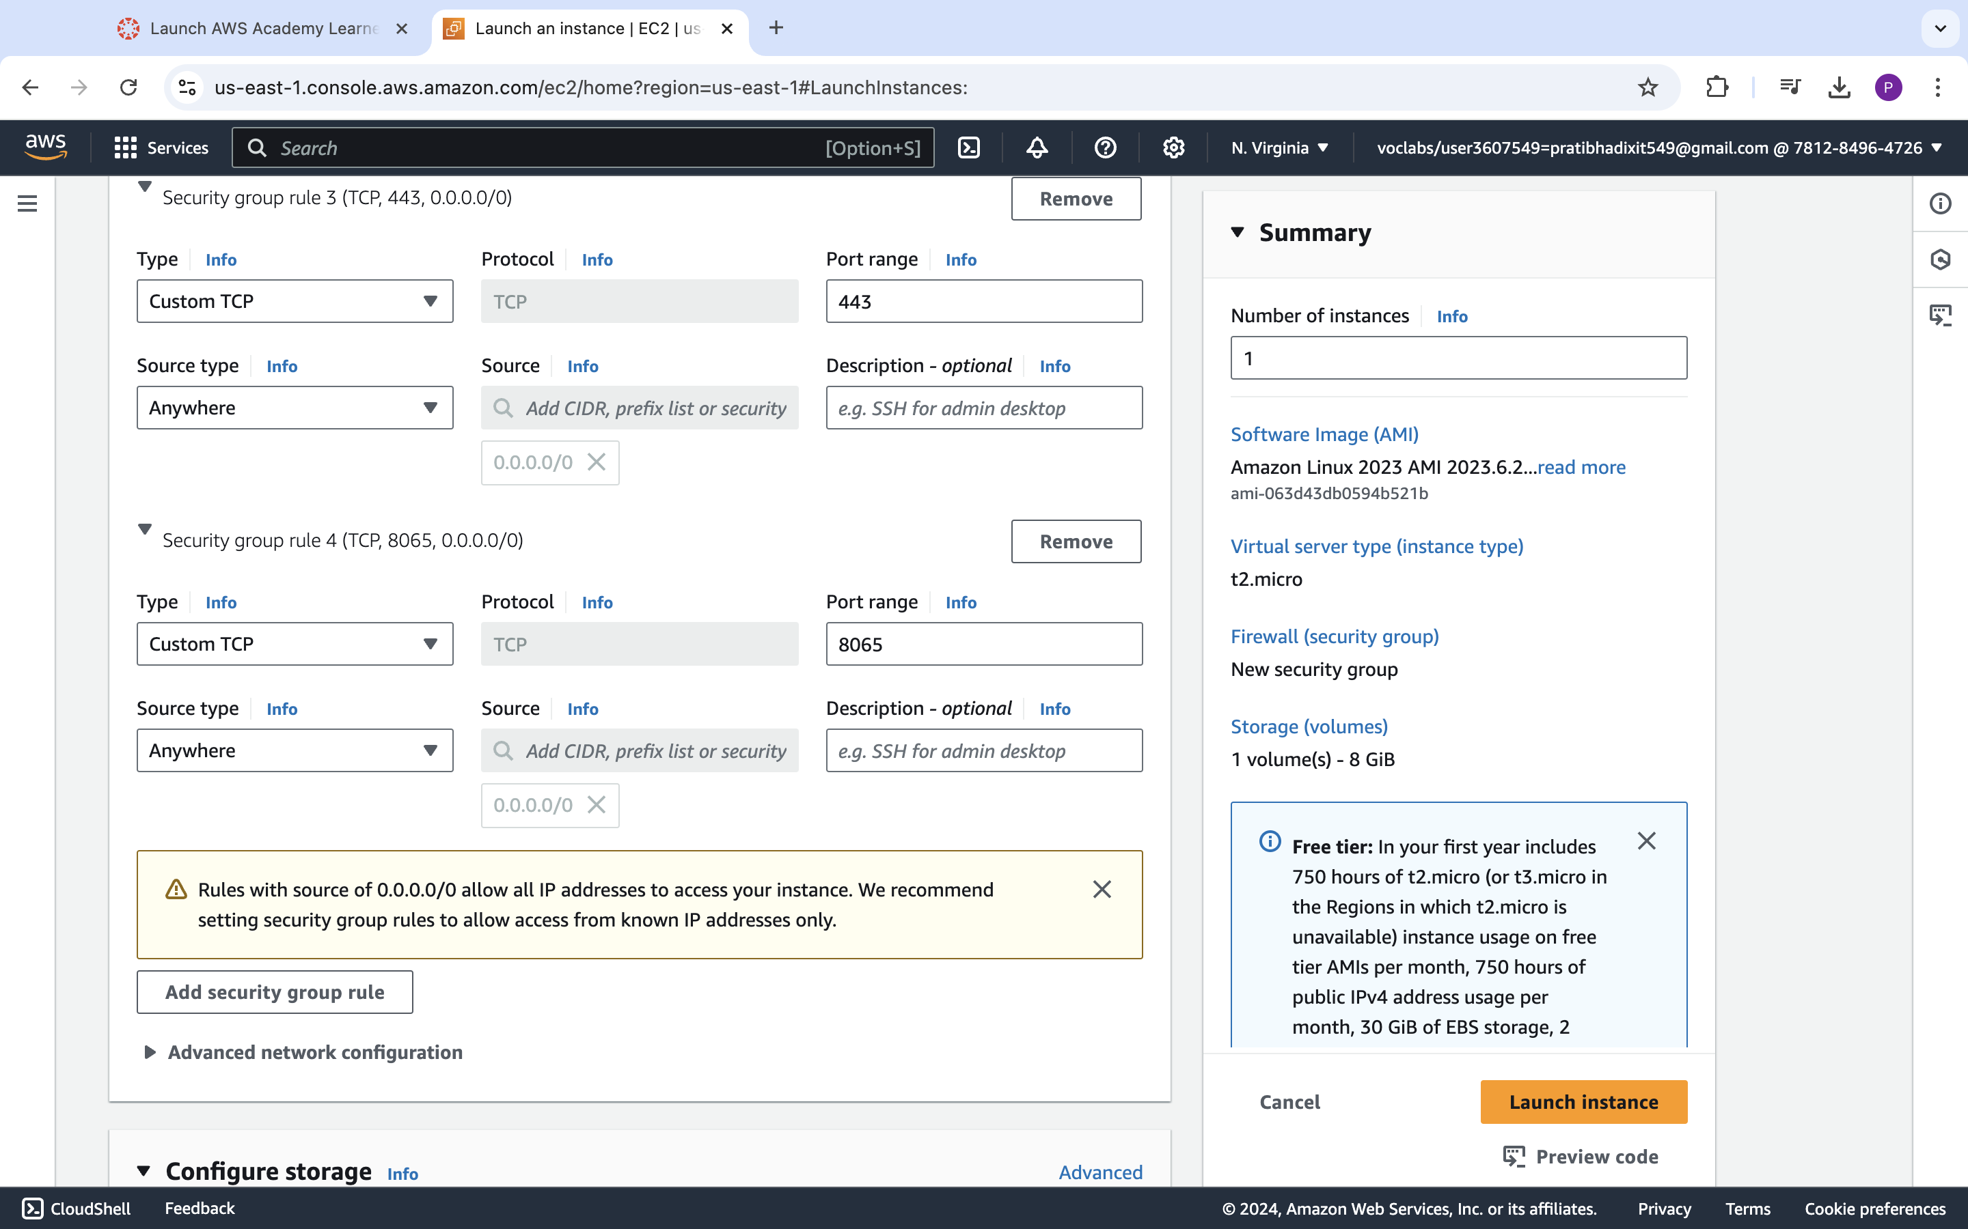

**<Insert screenshot a(4) here>**

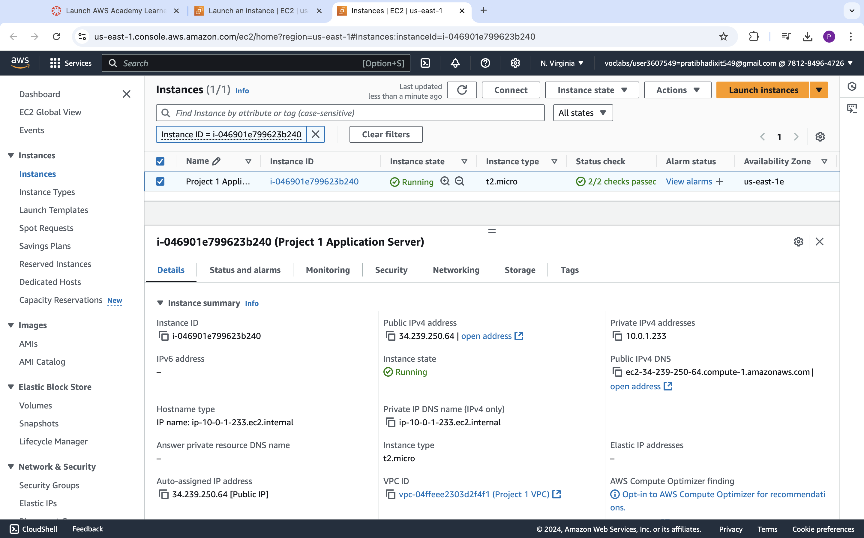

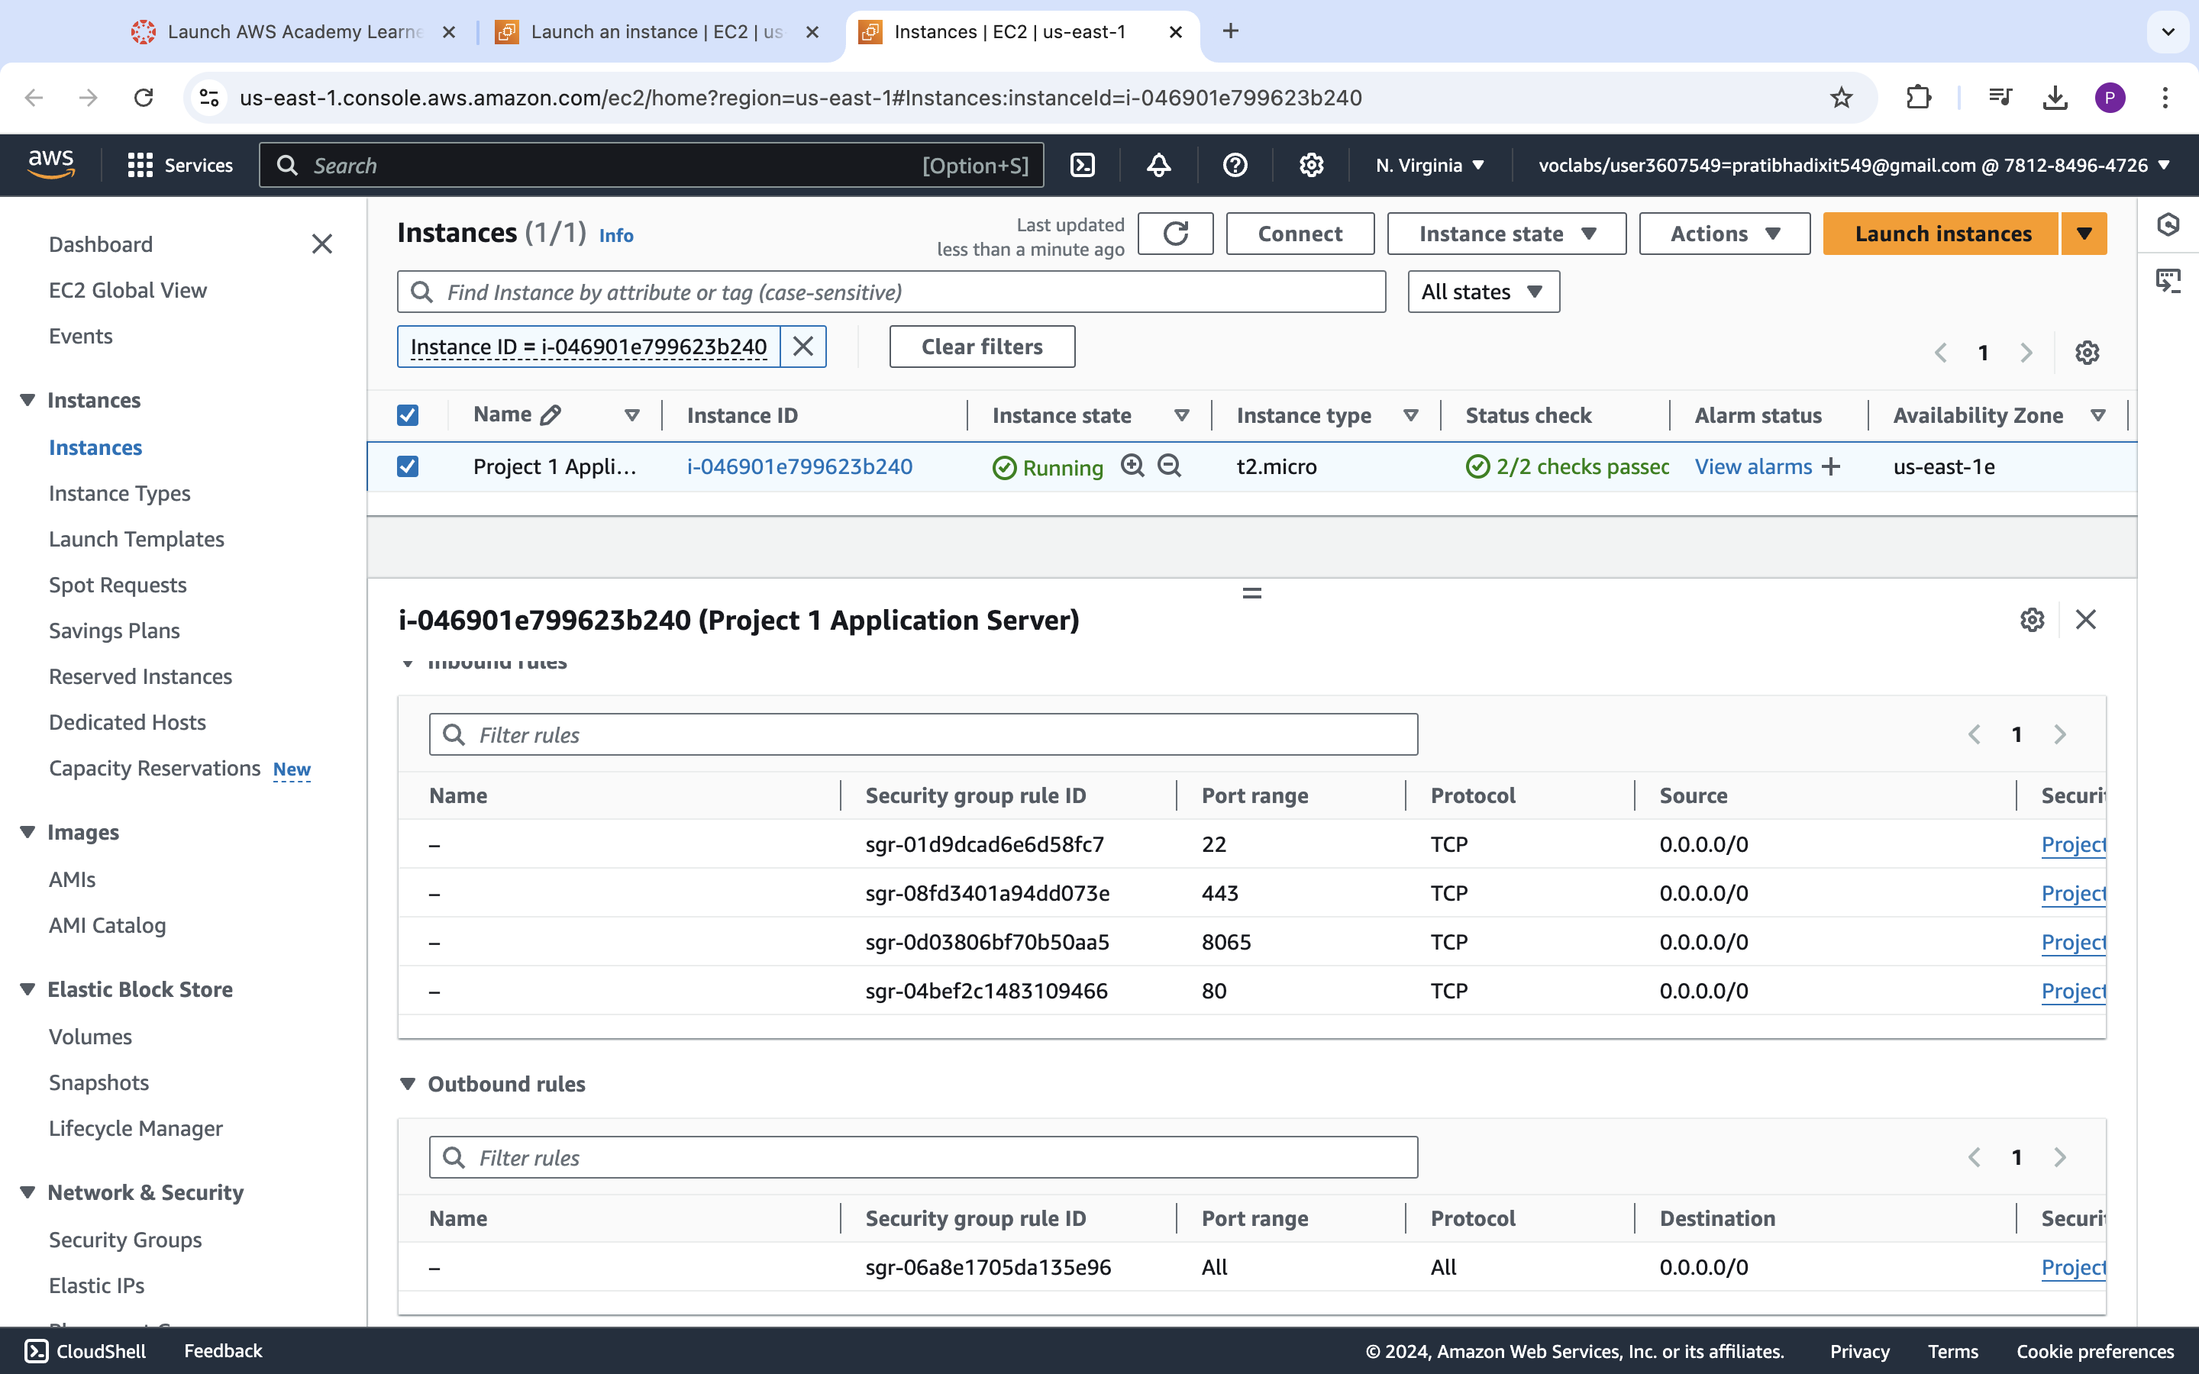

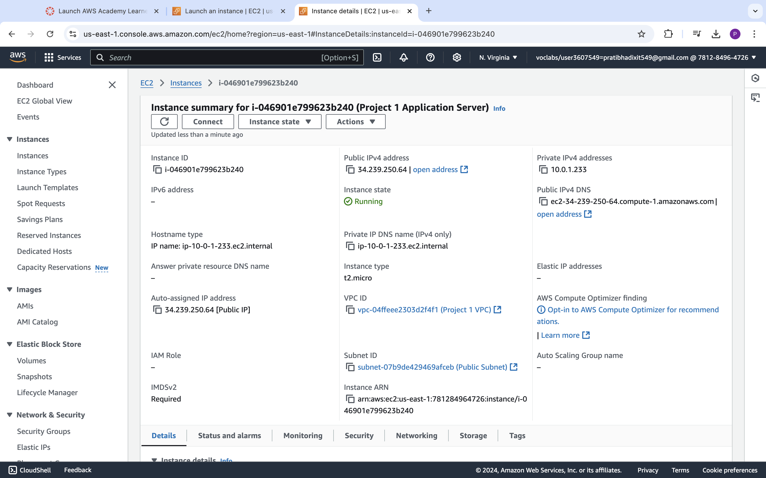

|  |  |  |  |  |
| --- | --- | --- | --- | --- |
| Step number | b |  |  |  |
| Step name | Creation of database server |  |  |  |
| Instructions | 1) Navigate to EC2 using the Services button at the top of the screen  2) Select Instances at the left side of the screen  3) Click on Launch Instance  - Select the AMI Amazon 2 Linux  - Select the instance type t2.micro  - Select Network as "Project 1 VPC" and subnet as "Private Subnet"  - For the security group, open the ports 80, 443,22 and 3306 for source set to "Anywhere"  4) Launch the instance by selecting the same pem file created in the previous step | | | |
| Expected screenshots | 1. AMI used 2. Instance configuration screen 3. Security group rules 4. Instance after creation |  |  |  |

**<Insert screenshot b(1) here>**

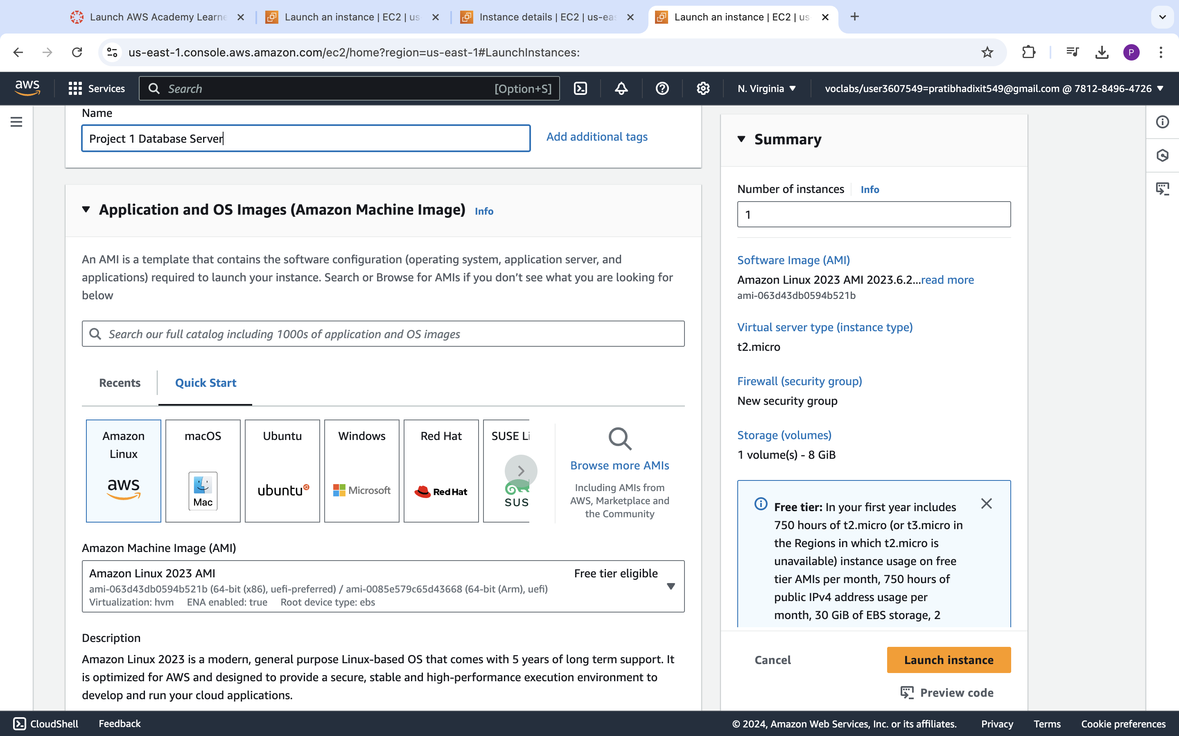

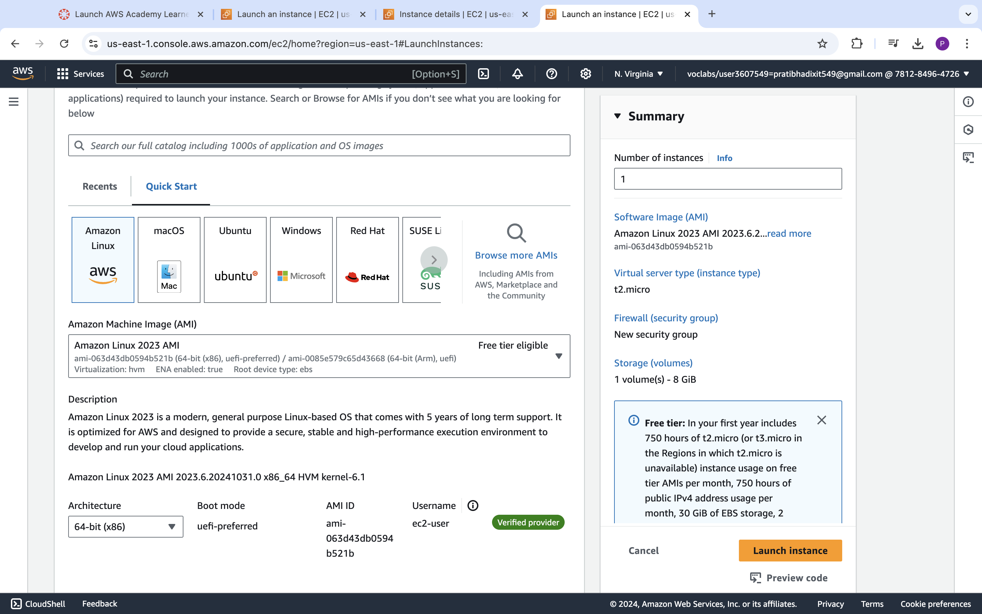

**<Insert screenshot b(2) here>**

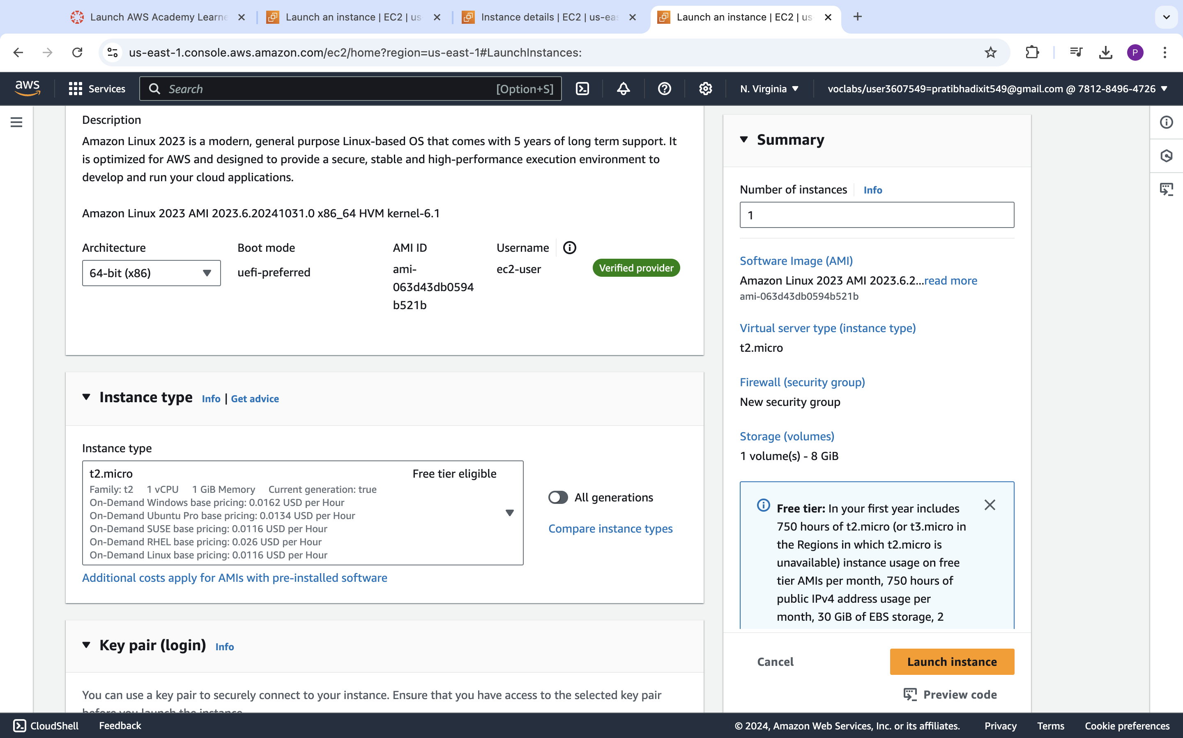

**<Insert screenshot b(3) here>**

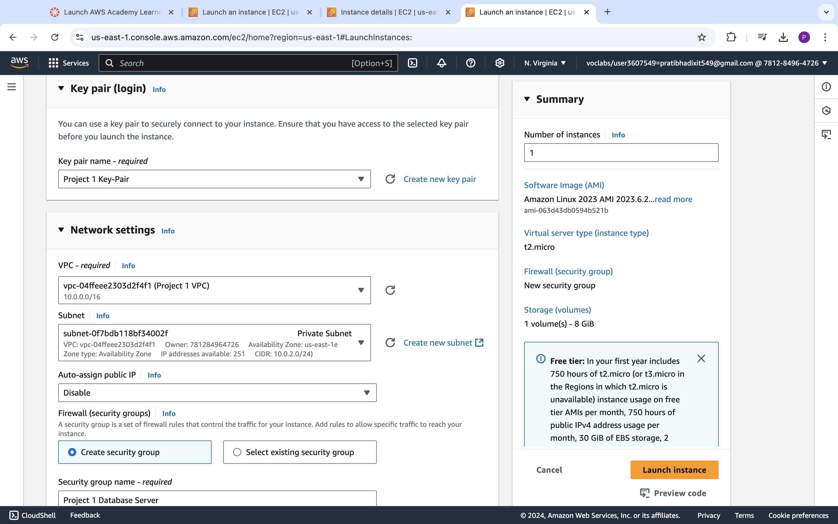

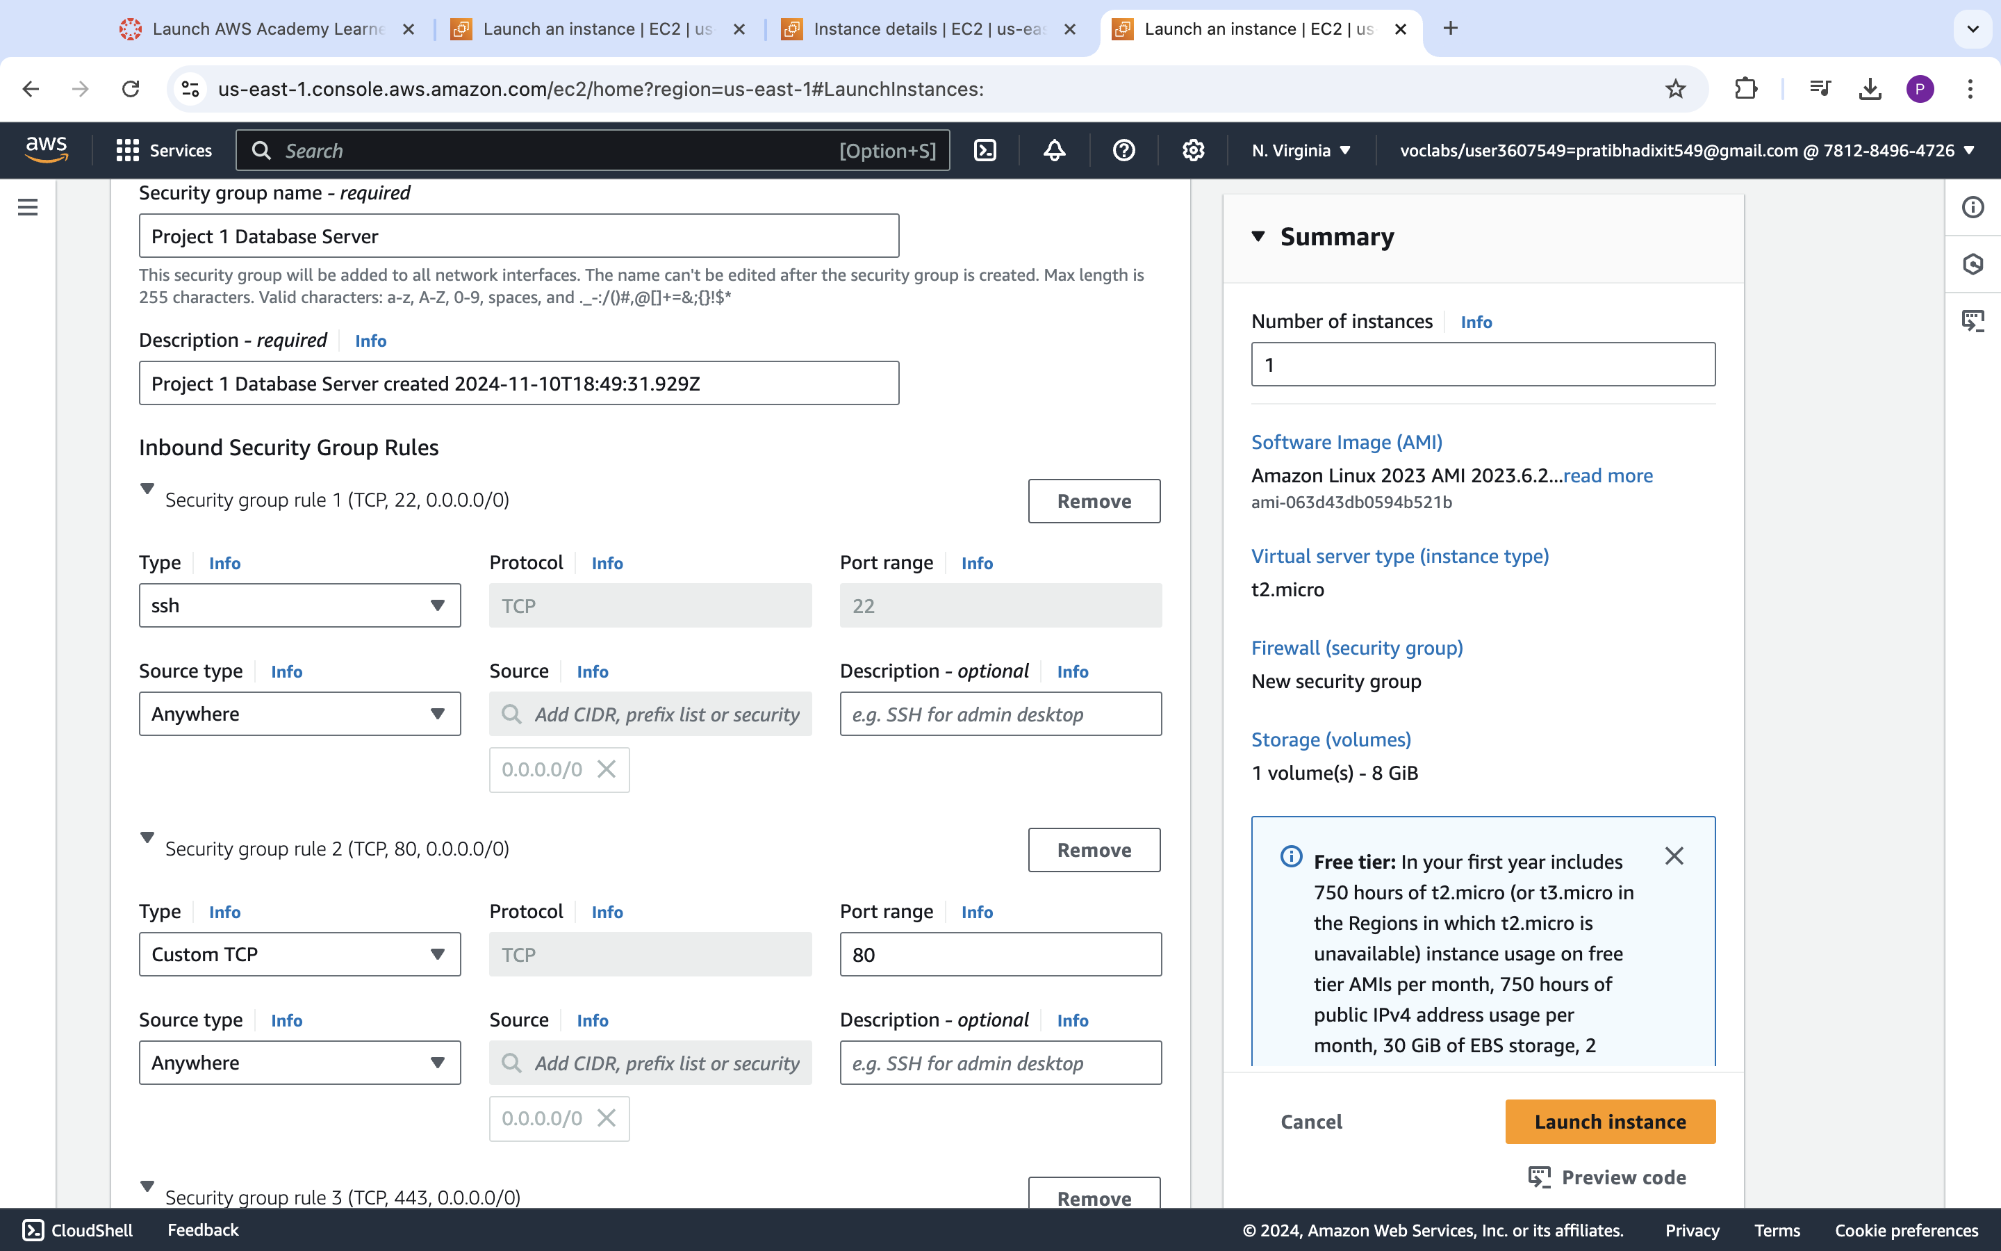

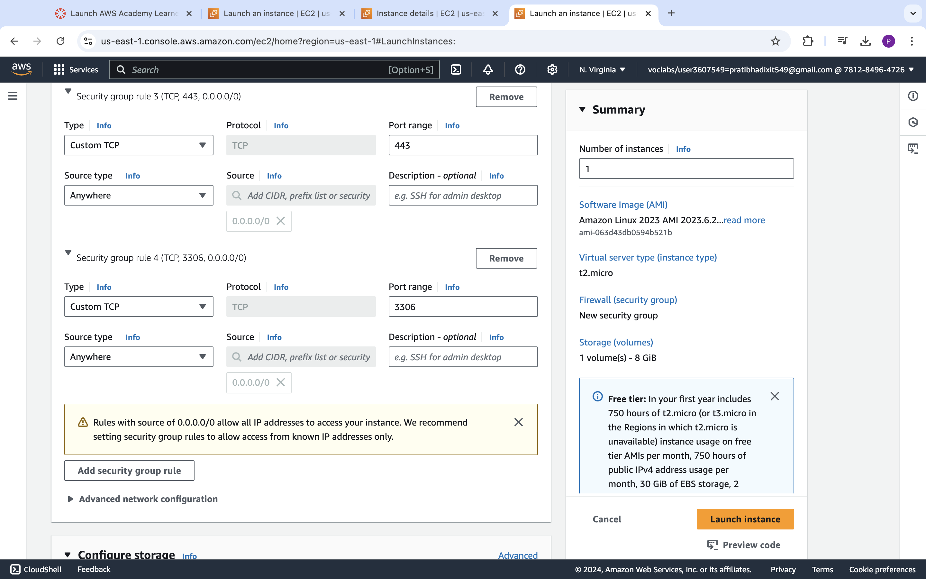

**<Insert screenshot b(4) here>**

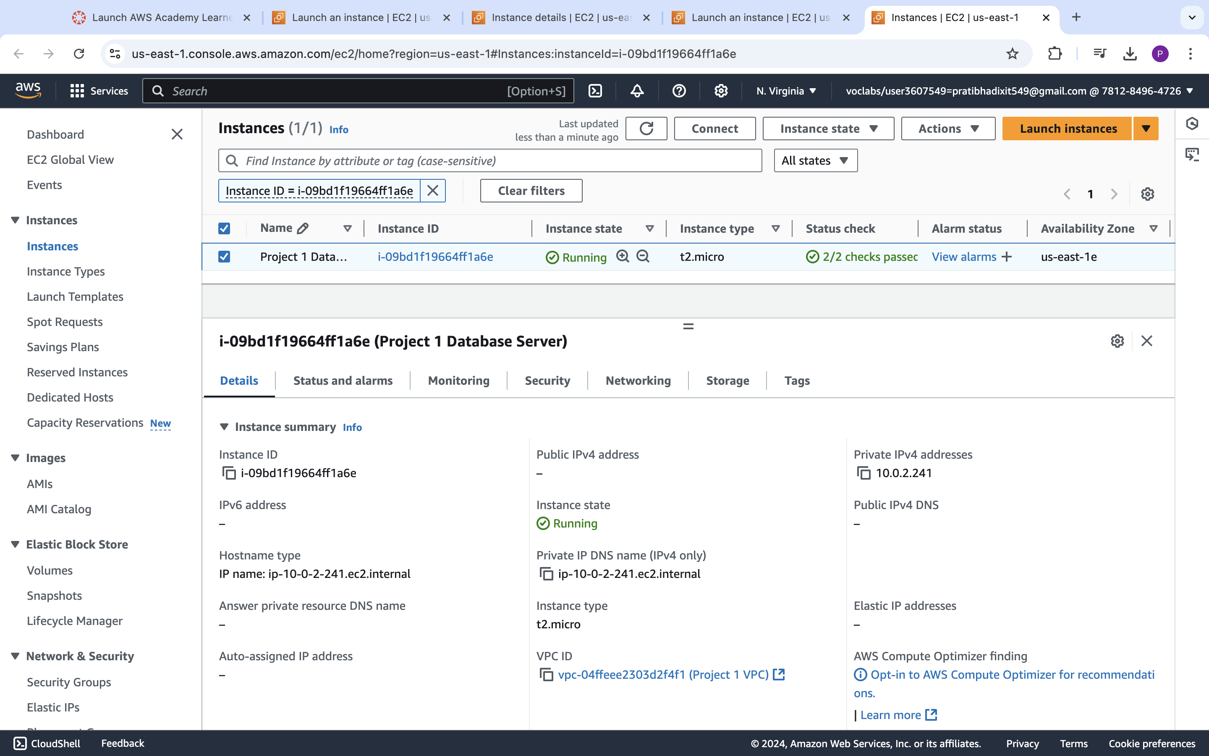

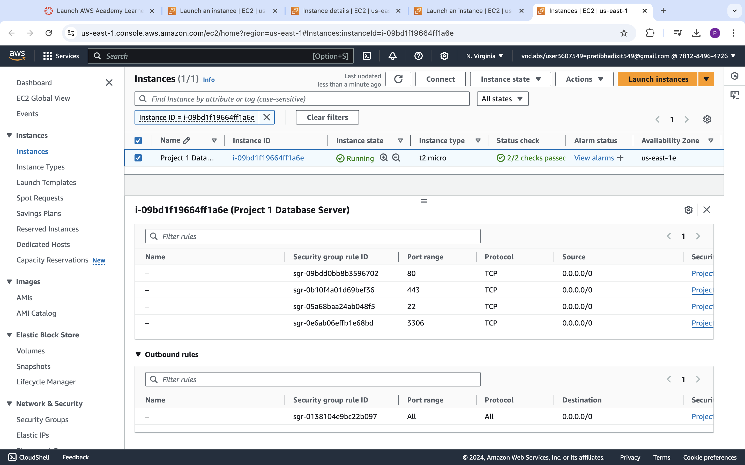

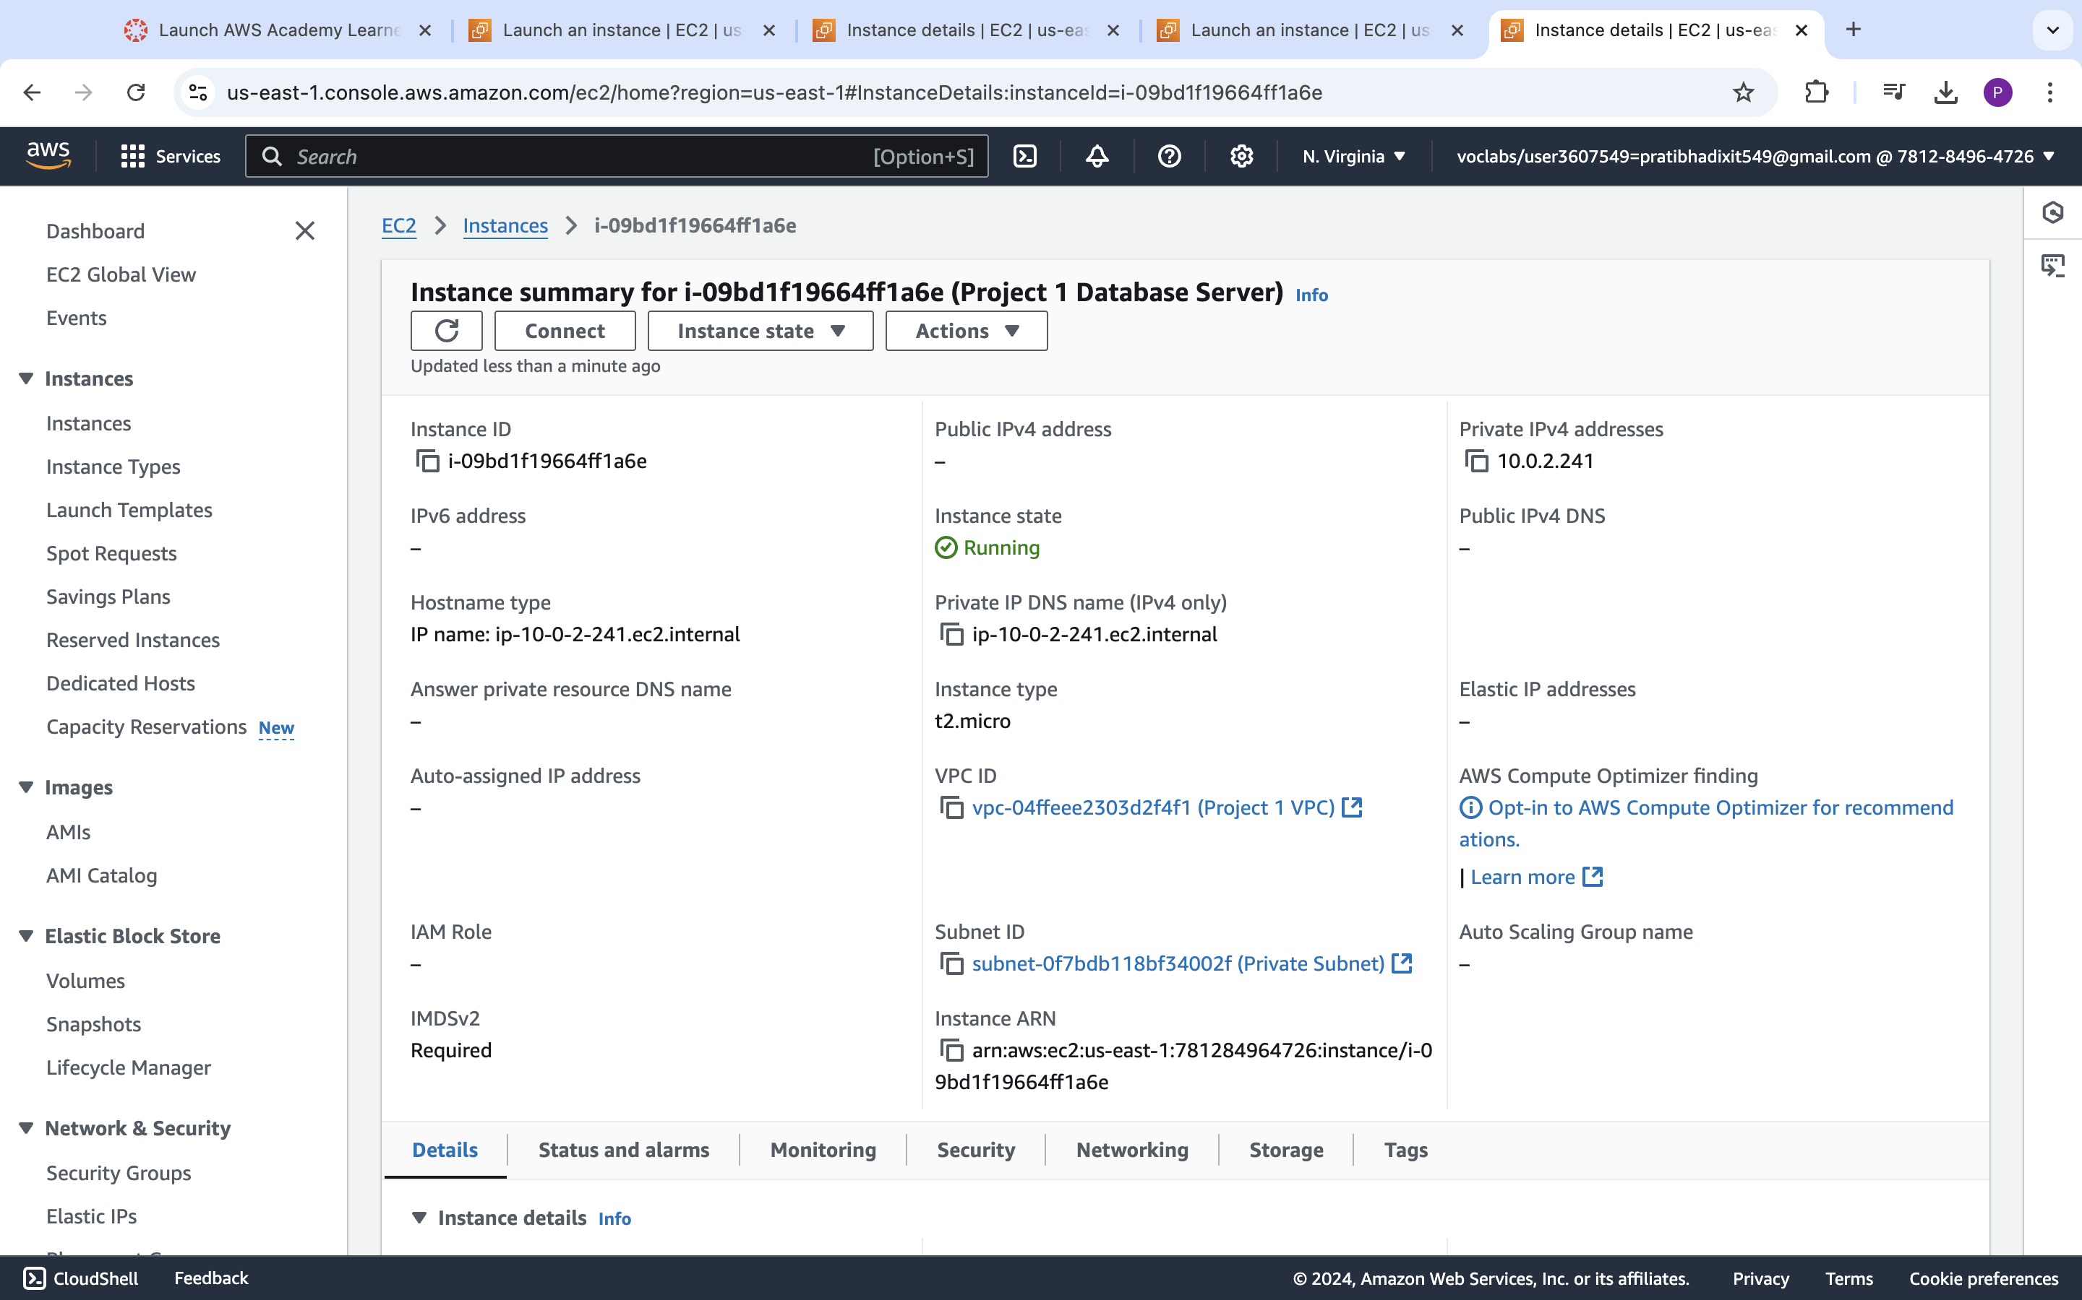

**Step 4: Application and Database Installation and Testing**

|  |  |  |  |  |
| --- | --- | --- | --- | --- |
| Step number | a |  |  |  |
| Step name | Installation and configuration of MySQL |  |  |  |
| Instructions | 1) Copy the database pem file into the application server using the below command  *scp -i <application server pem file> <database server pem file > ec2-user@<application server public IP>:/home/ec2-user*  2) Log into the application server using SSH/Putty  3) From the application server, log into the database server using the pem file copied in step 1and the private IP address of the database server with the following command  *ssh -i <database server pem file> ec2-user@<private IP of database server>*  4) Enter the following commands to install and configure MySQL on the database server  *sudo yum update* *wget http://dev.mysql.com/get/mysql57-community-release-el7-9.noarch.rpm sudo yum localinstall mysql57-community-release-el7-9.noarch.rpm -y*  *sudo yum install mysql-community-server -y --nogpgcheck*  *sudo systemctl start mysqld.service*  Run the below command to retrieve a temporary password for MySQL *sudo grep 'temporary password' /var/log/mysqld.log | rev | cut -d" " -f1 | rev | tr -d "."*  Log in to MySQL with the below command and enter the above password when prompted *mysql -u root -p*  Enter the below command after you login to MySQL  *ALTER USER 'root'@'localhost' IDENTIFIED BY 'Password42!';*  Type ‘exit’ into the MySQL prompt and press Enter to exit out of the MySQL environment. Enter the below commands to complete the setup. Ignore any warning messages you receive.  *wget https://d6opu47qoi4ee.cloudfront.net/install_mysql_linux.sh*  *chmod 777 install_mysql_linux.sh*  *sudo ./install_mysql_linux.sh*  5) Type *exit* to exit the database server and go back to the application server | | | |
| Expected screenshots | 1. Installation of MySQL 2. Retrieving the temporary password 3. Executing the provided script |  |  |  |

**<Insert screenshot a(1) here>**

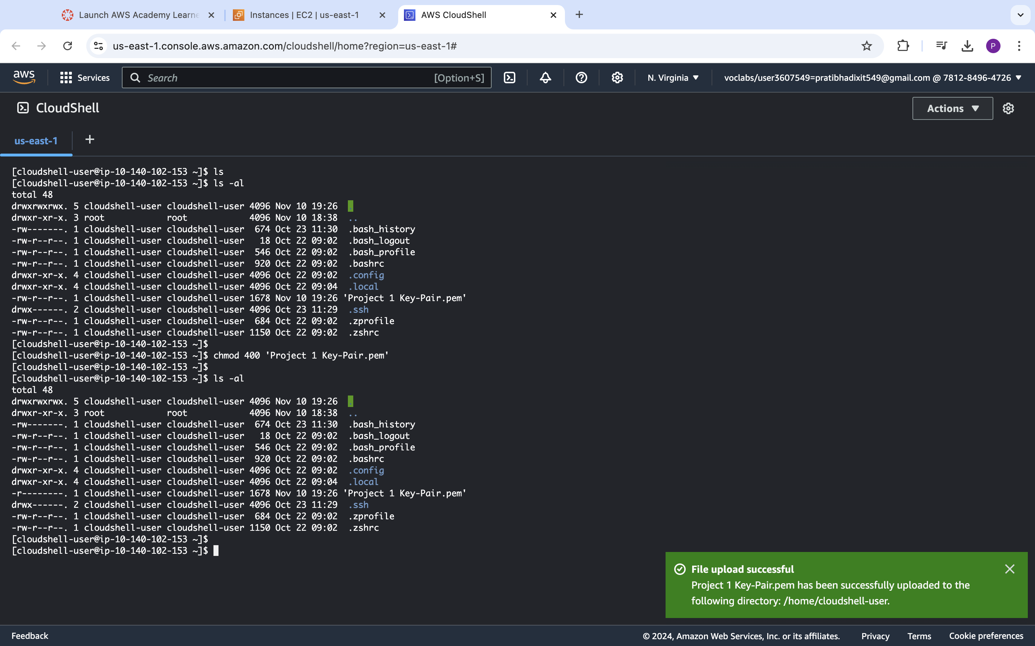



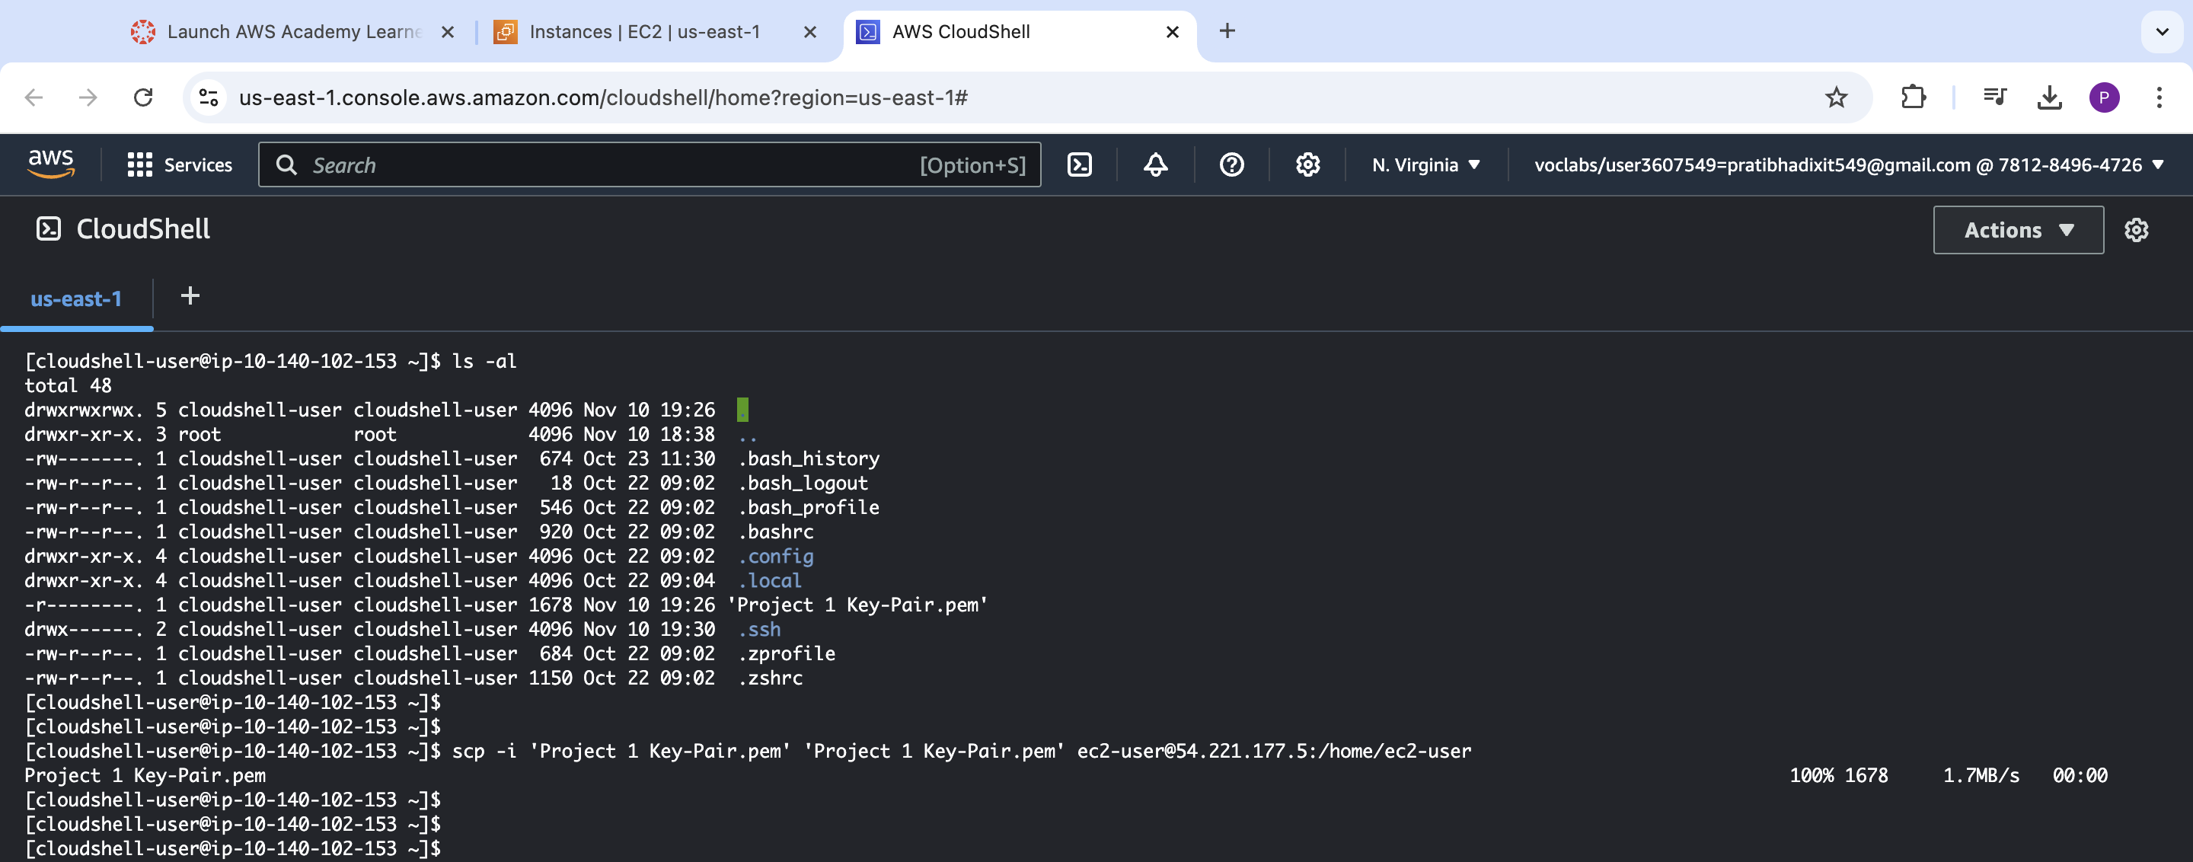

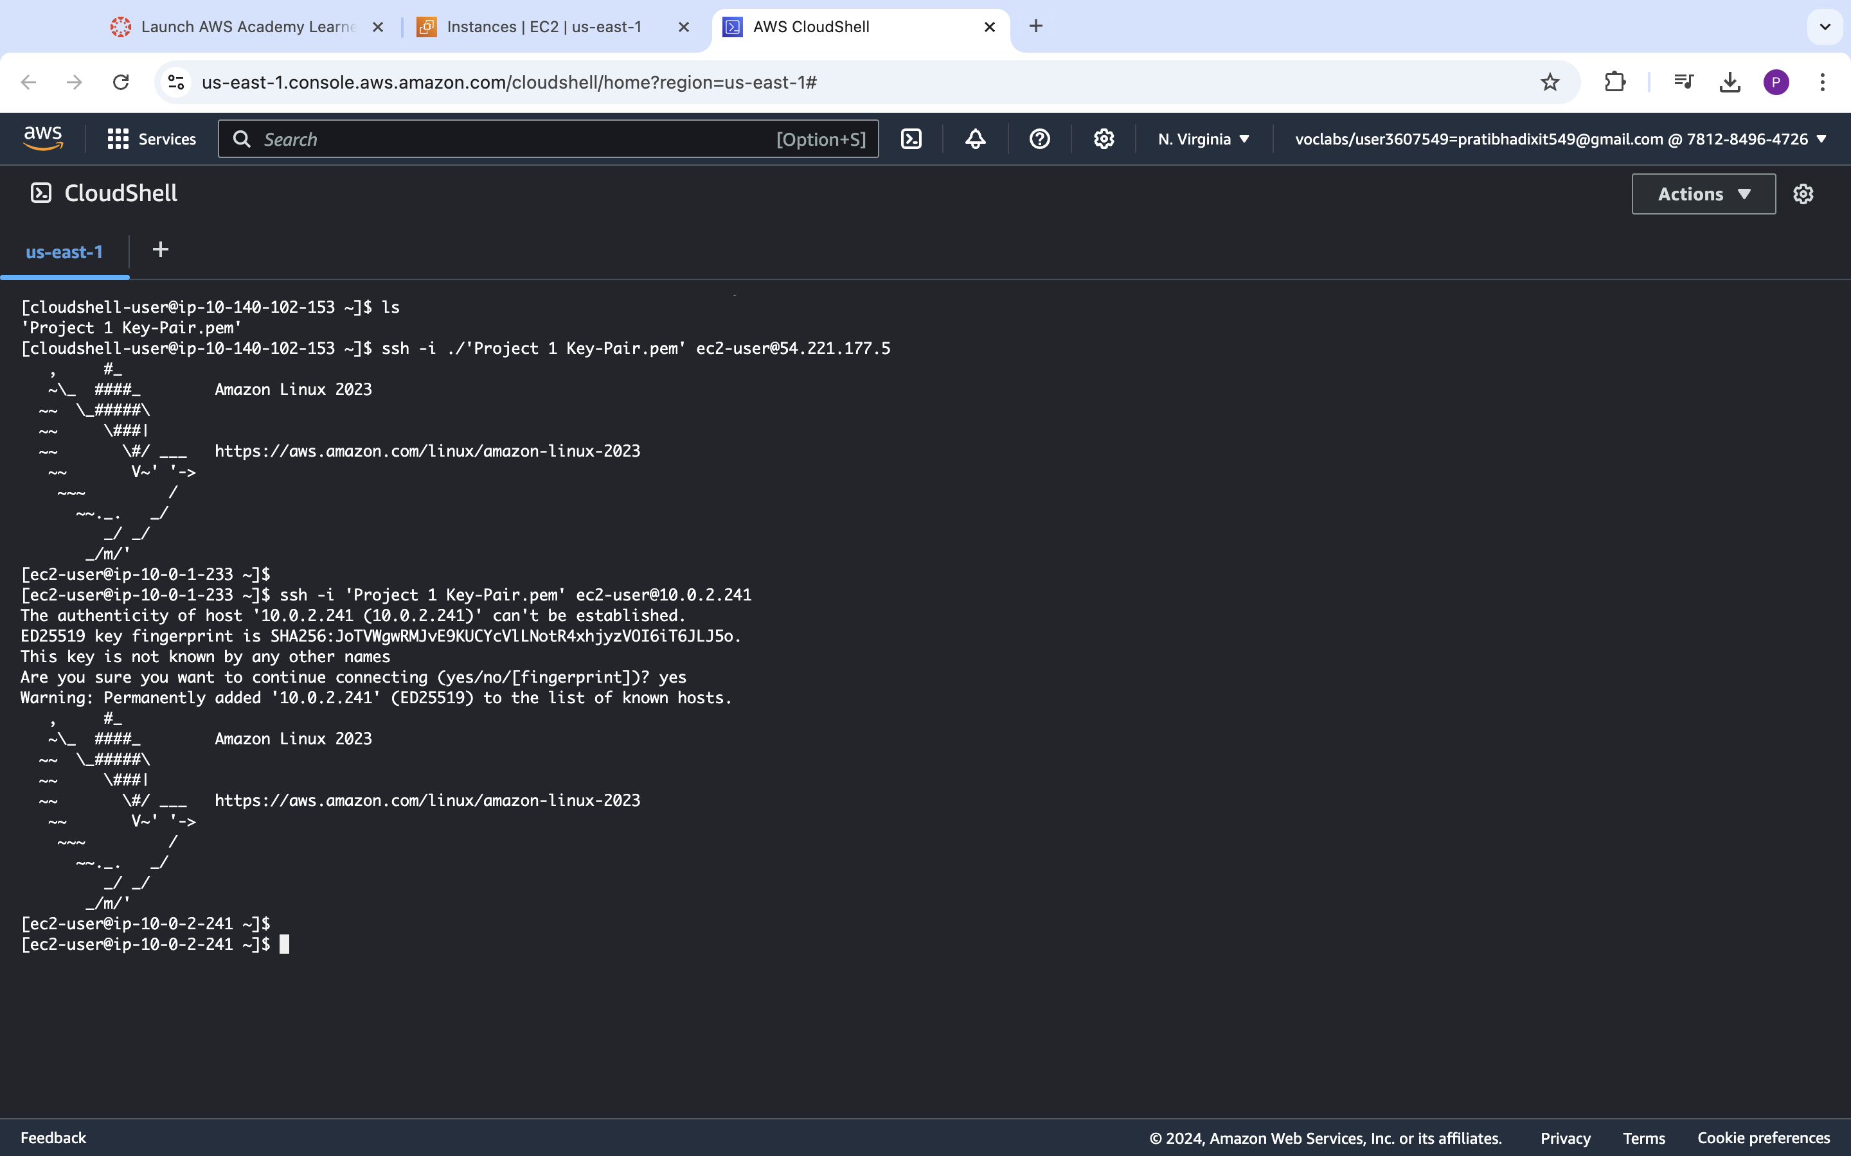

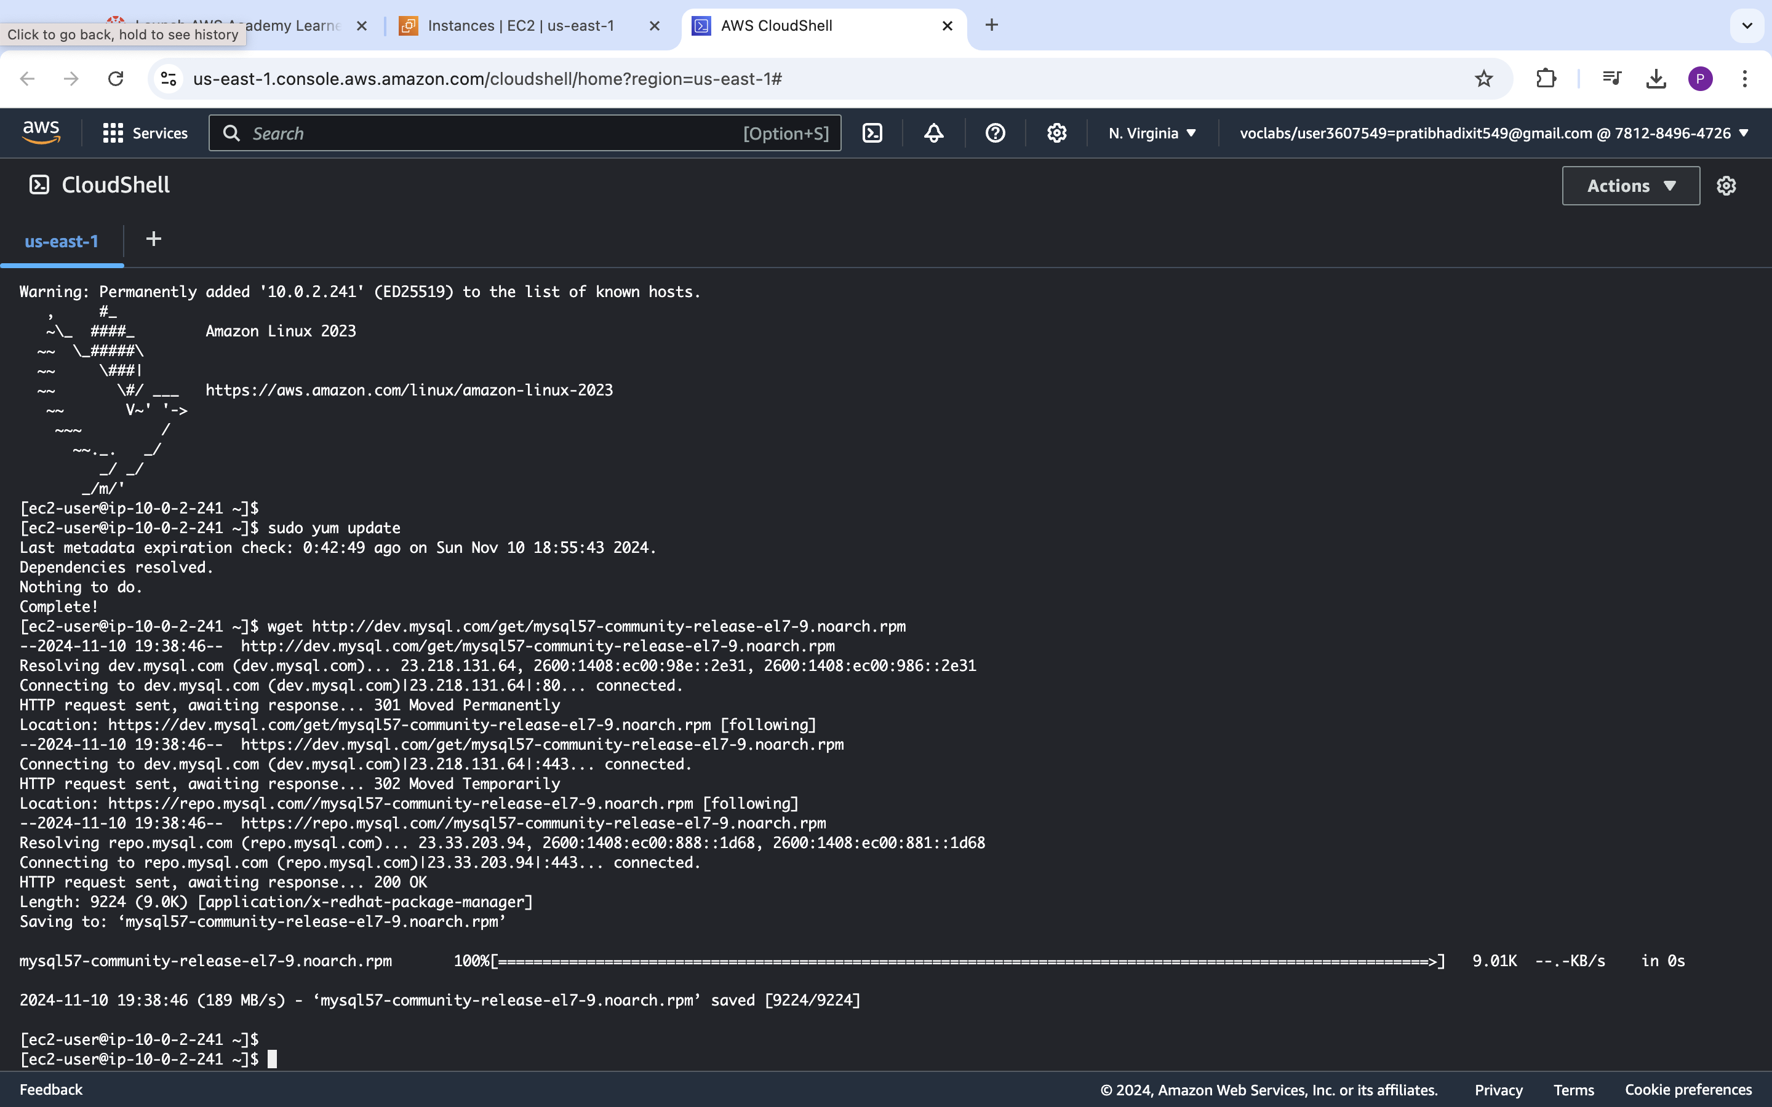

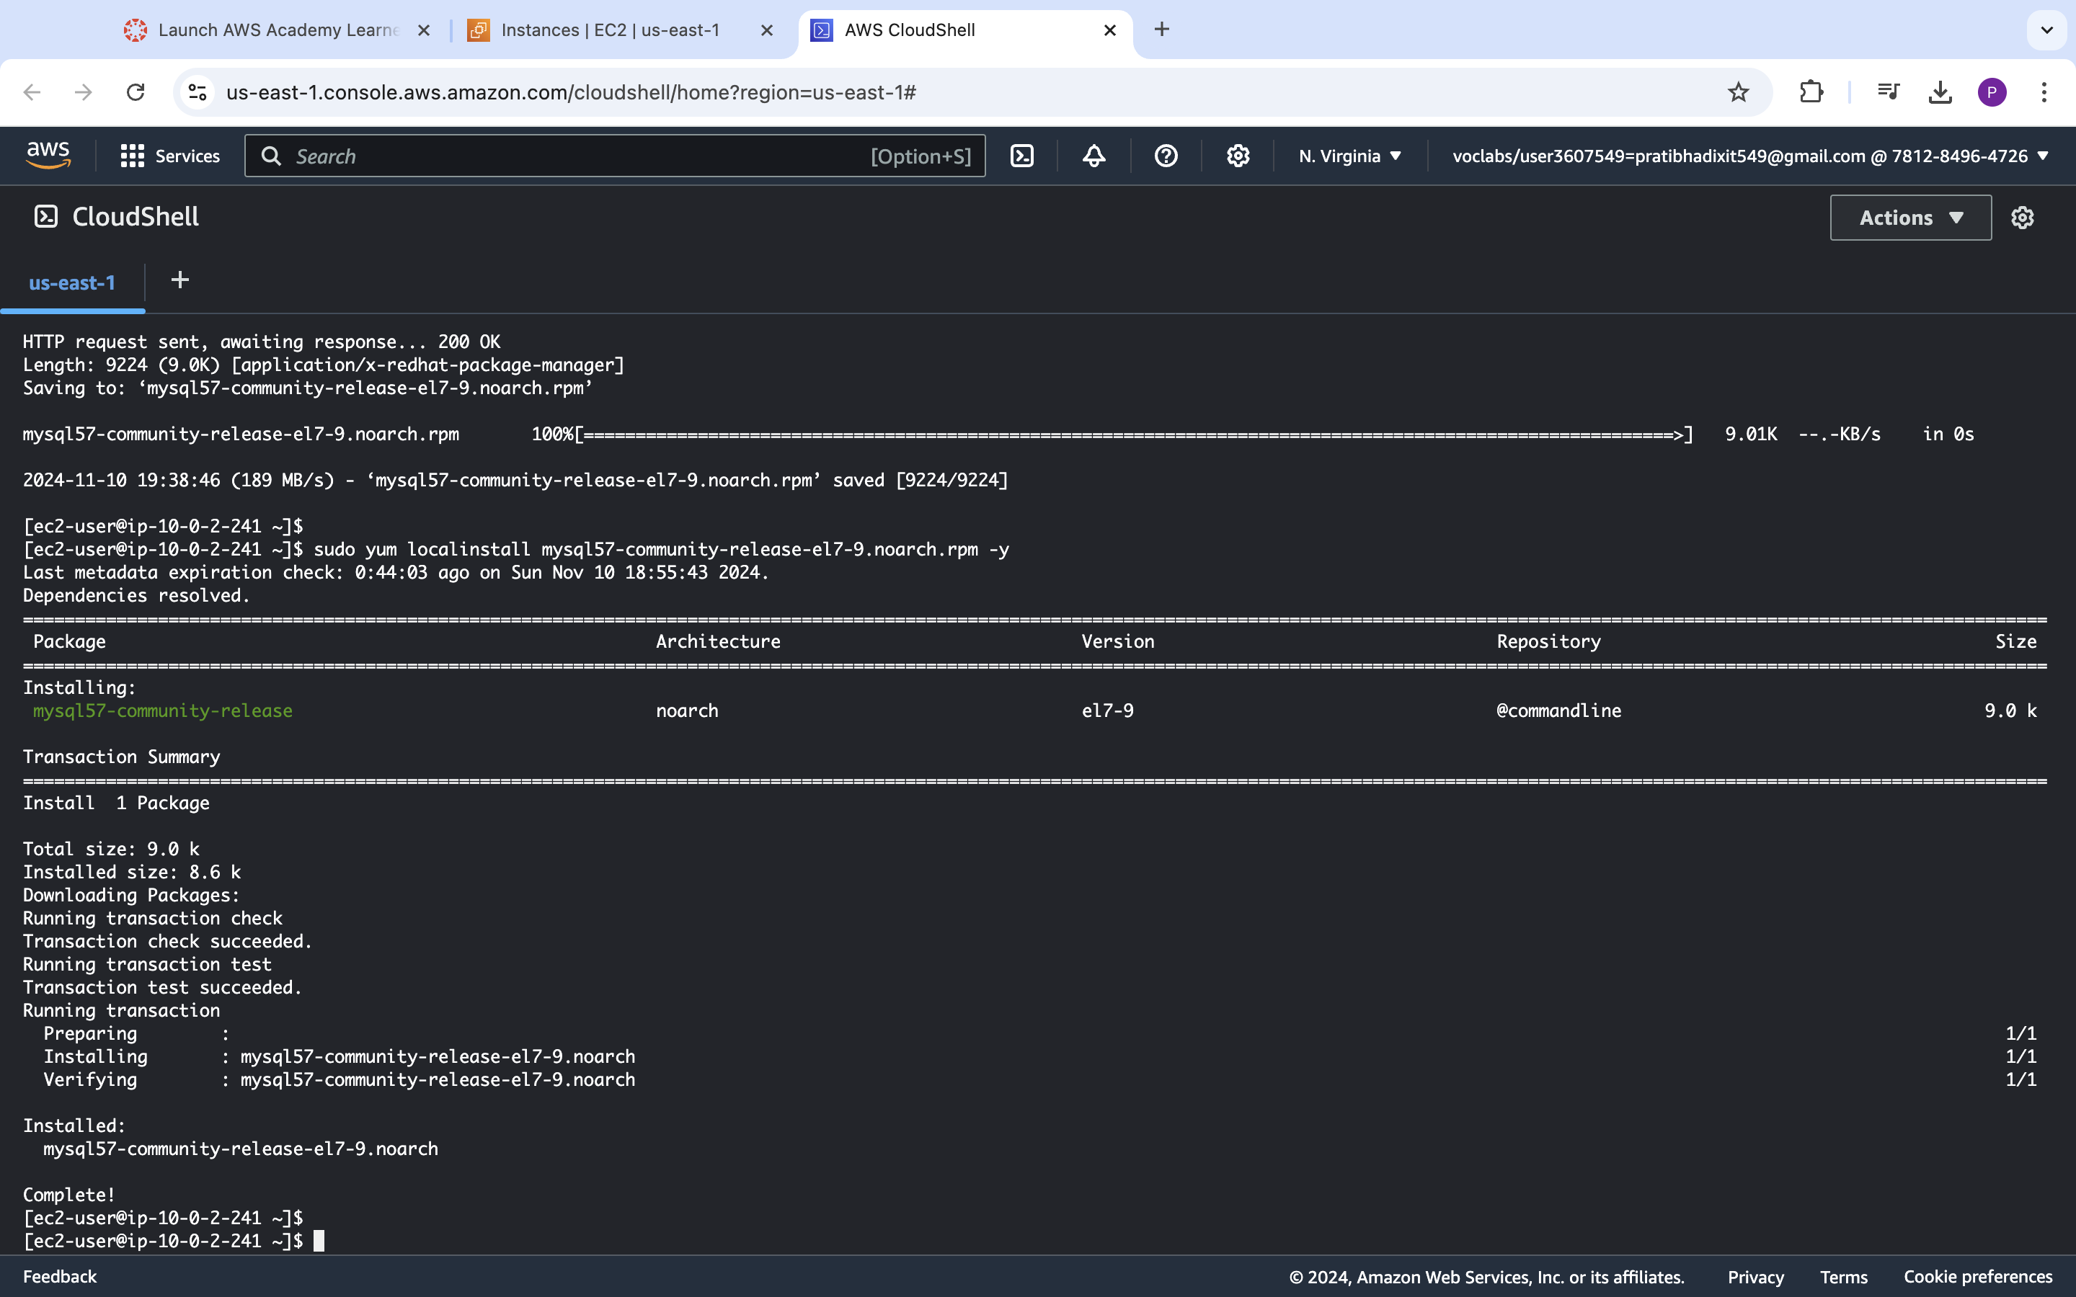

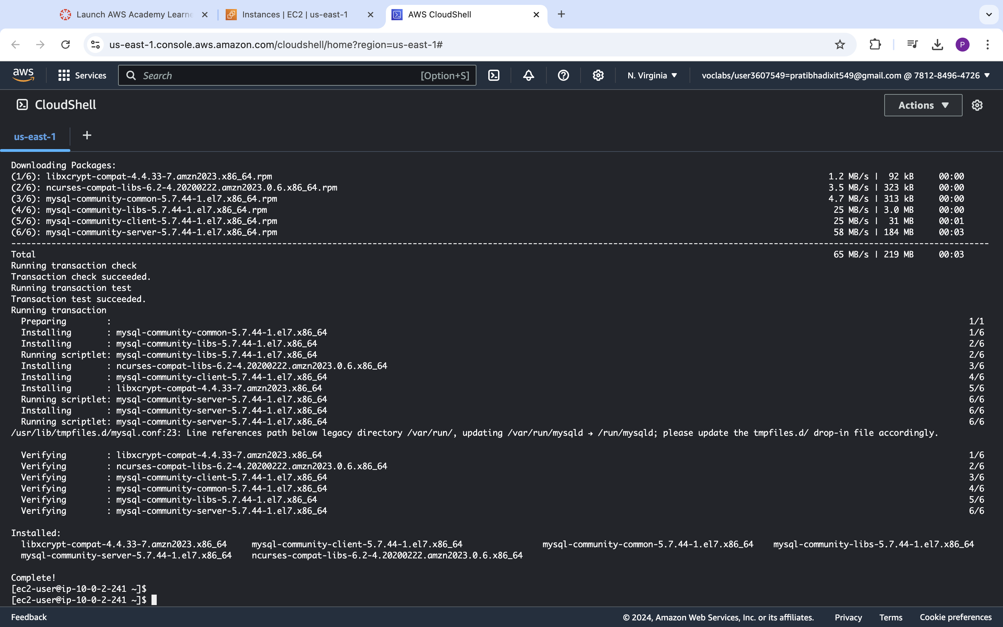

**<Insert screenshot a(2) here>**

**Command Executed ::** *sudo grep 'temporary password' /var/log/mysqld.log* **->** receiving Error in password as dot was getting removed from temporary password hence used below command to get desired results

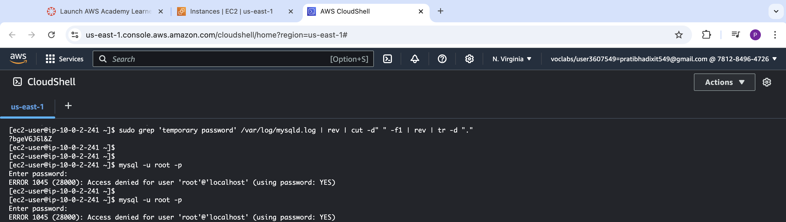

**Command Executed ::** *sudo grep 'temporary password' /var/log/mysqld.log* -> for successful required result

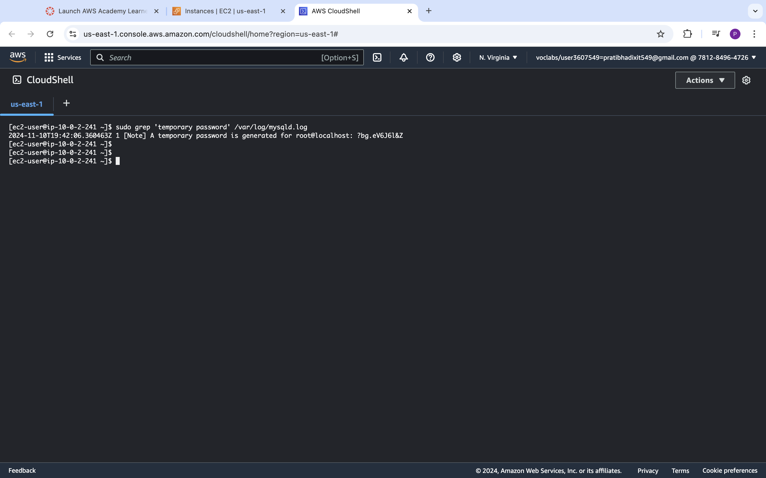

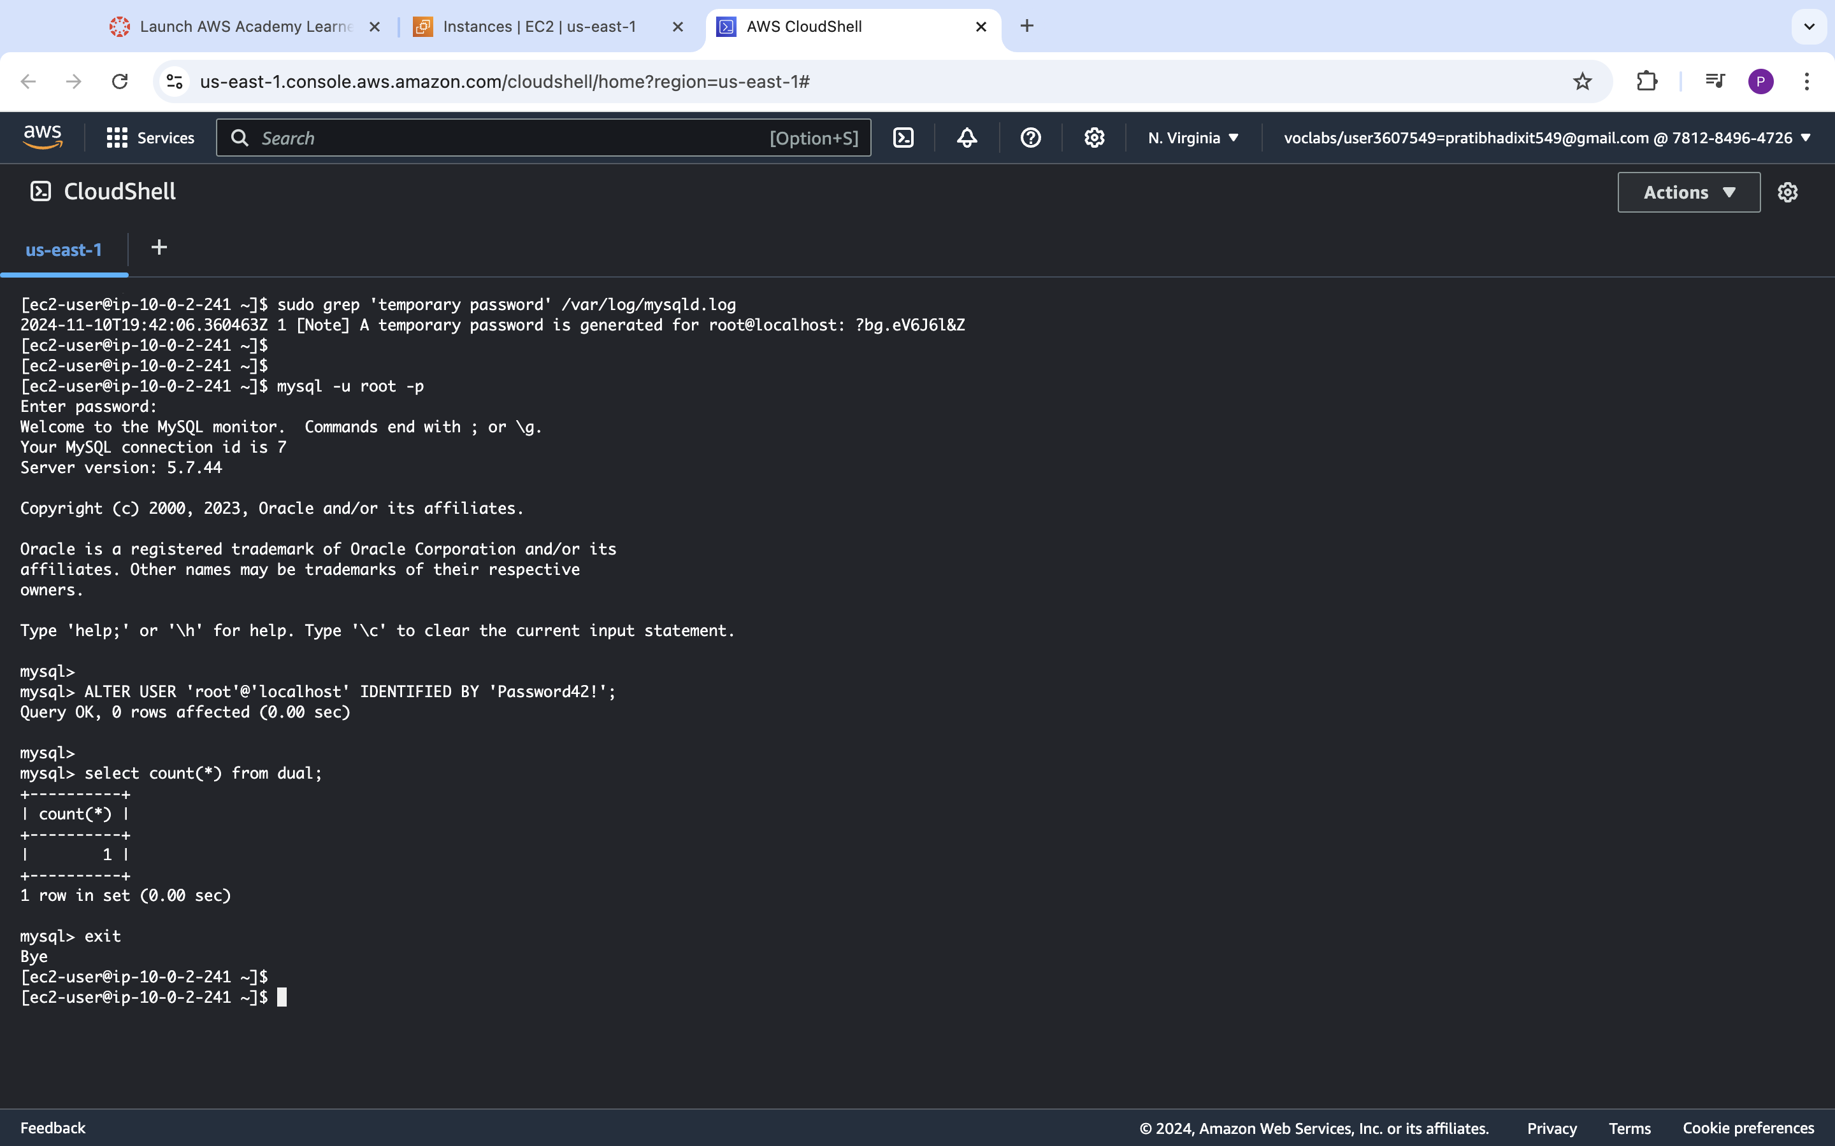

**<Insert screenshot a(3) here>**

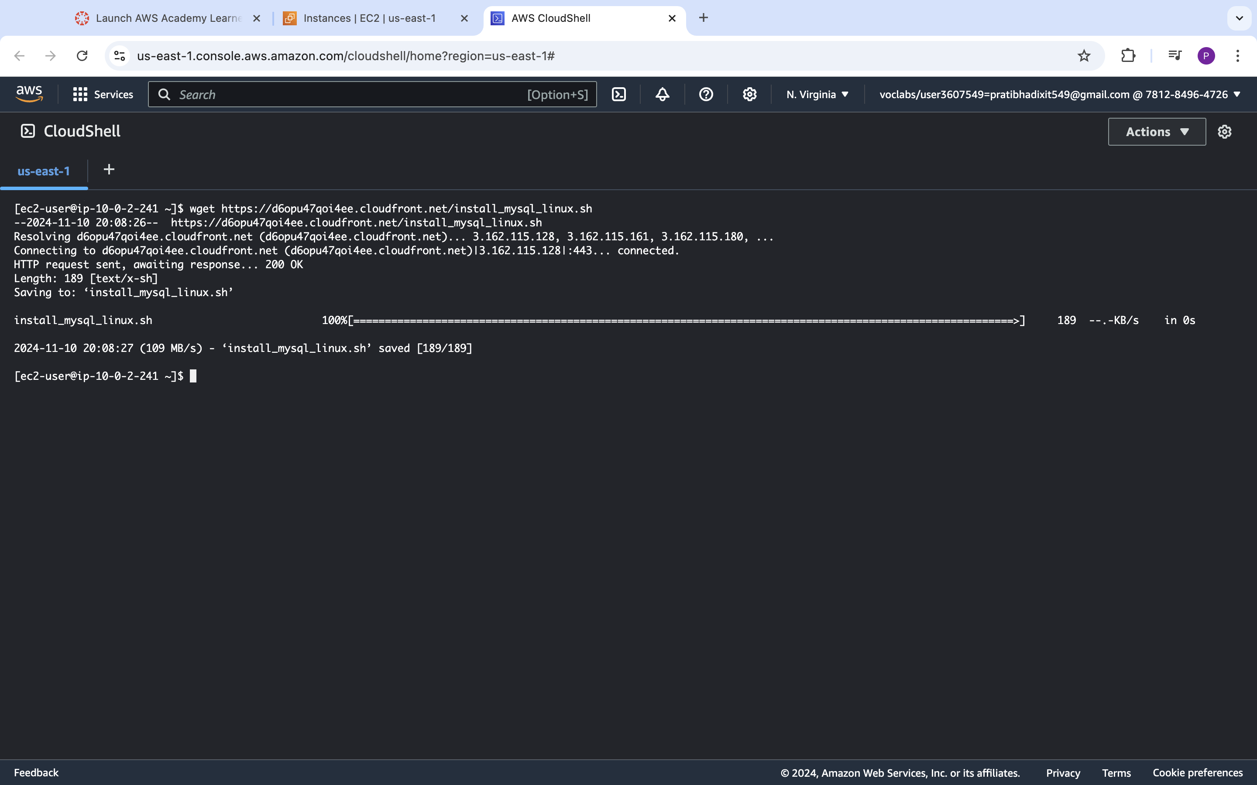

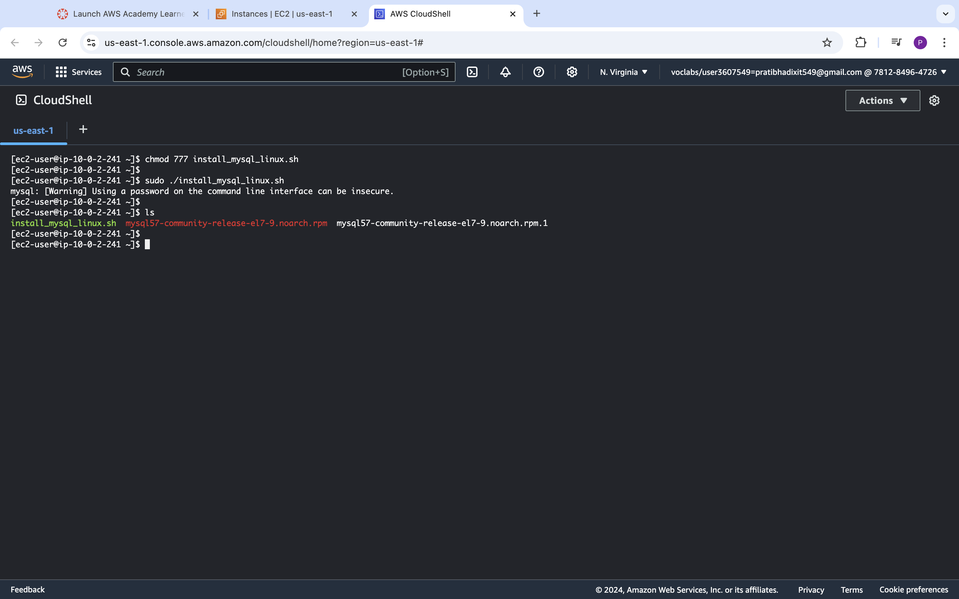

|  |  |  |  |  |
| --- | --- | --- | --- | --- |
| Step number | b |  |  |  |
| Step name | Installation and configuration of Mattermost |  |  |  |
| Instructions | 1) Enter the following commands after logging into the application server via SSH to install and configure Mattermost  *wget https://d6opu47qoi4ee.cloudfront.net/install_mattermost_linux.sh*  *sudo yum install dos2unix -y*  *sudo dos2unix install_mattermost_linux.sh*  *chmod 700 install_mattermost_linux.sh*  *sudo ./install_mattermost_linux.sh <private IP of MySQL server>*  Example : sudo ./*install_mattermost_linux* 173.65.34.7  *sudo chown -R mattermost:mattermost /opt/mattermost*  *sudo chmod -R g+w /opt/mattermost*  *cd /opt/mattermost*  *sudo -u mattermost ./bin/mattermost*  2) Check whether the server has been successfully deployed by navigating to the following URL in your web browser. The web page might take a couple of minutes to load.  <public IP of the application server>:8065 | | | |
|  |
|  |
|  |
|  |
|  |
|  |
|  |
|  |
|  |  |  |  |  |
| Expected screenshots | 1. Executing the script 2. Starting the Mattermost server 3. Accessing the application via web browser |  |  |  |

**<Insert screenshot b(1) here>**

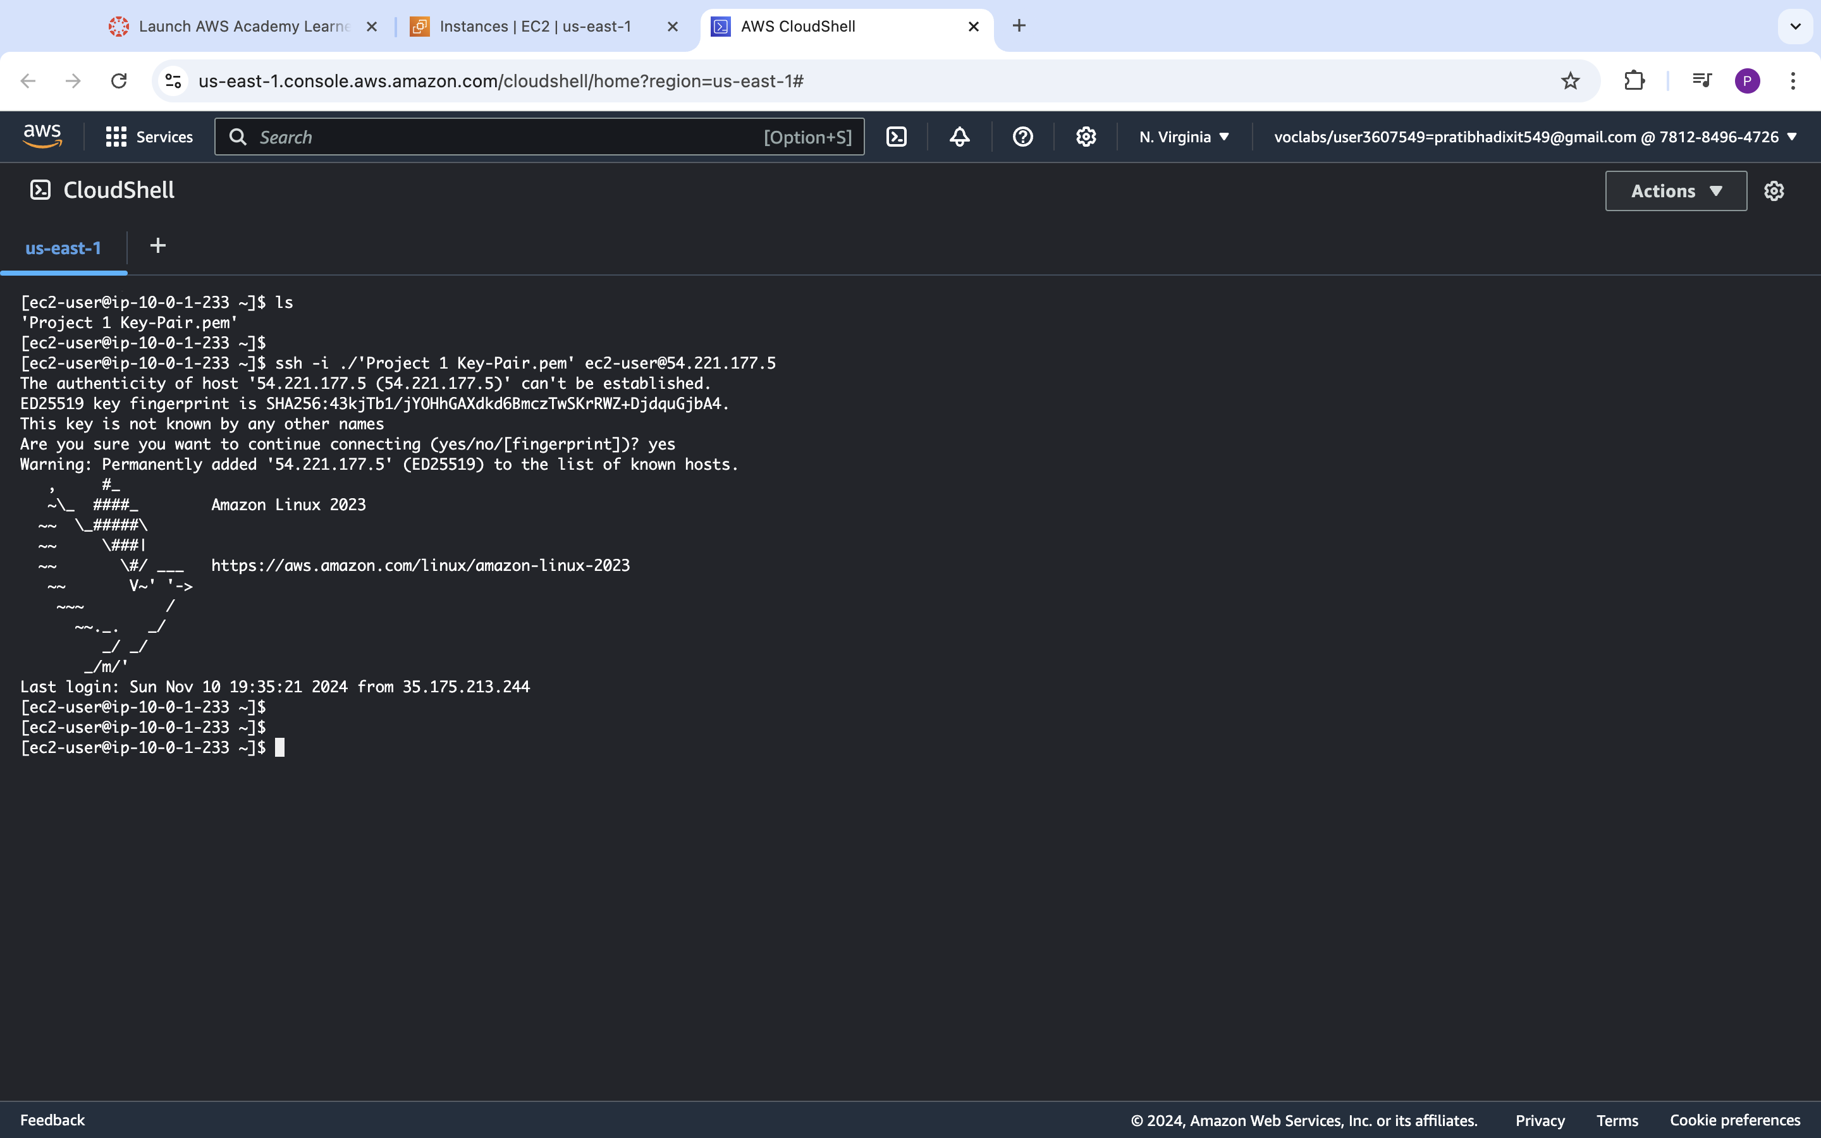

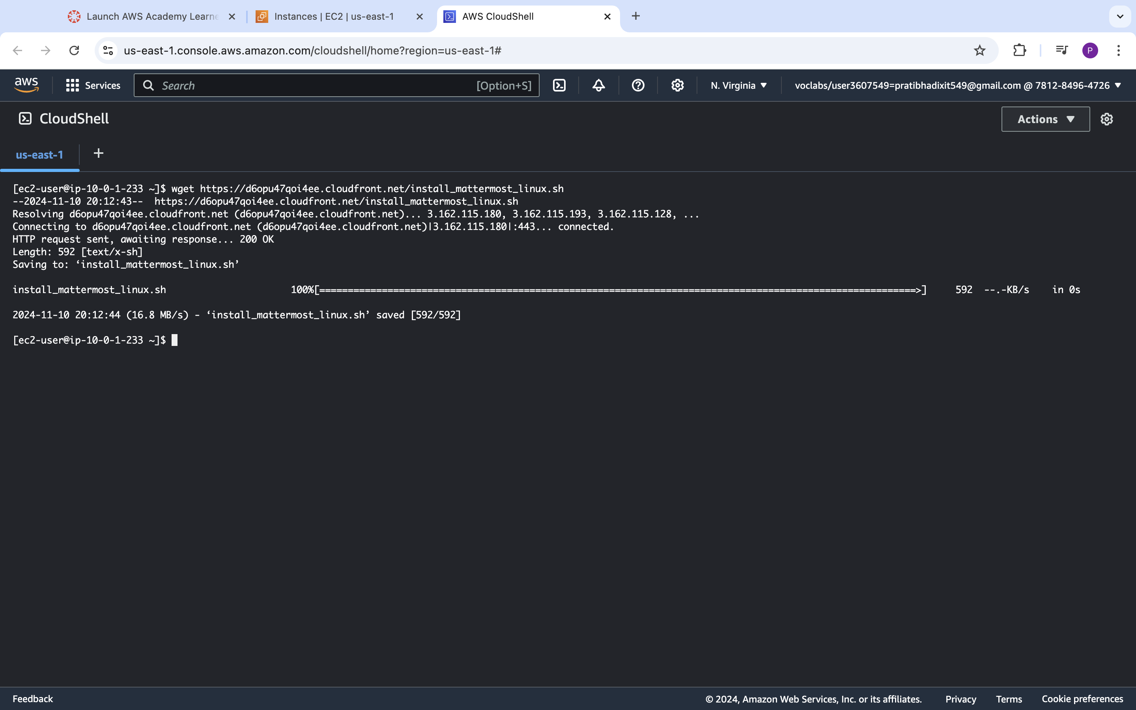

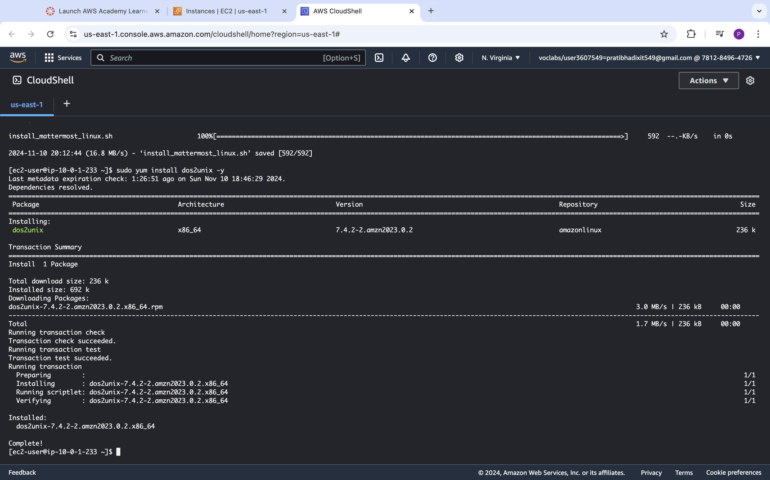

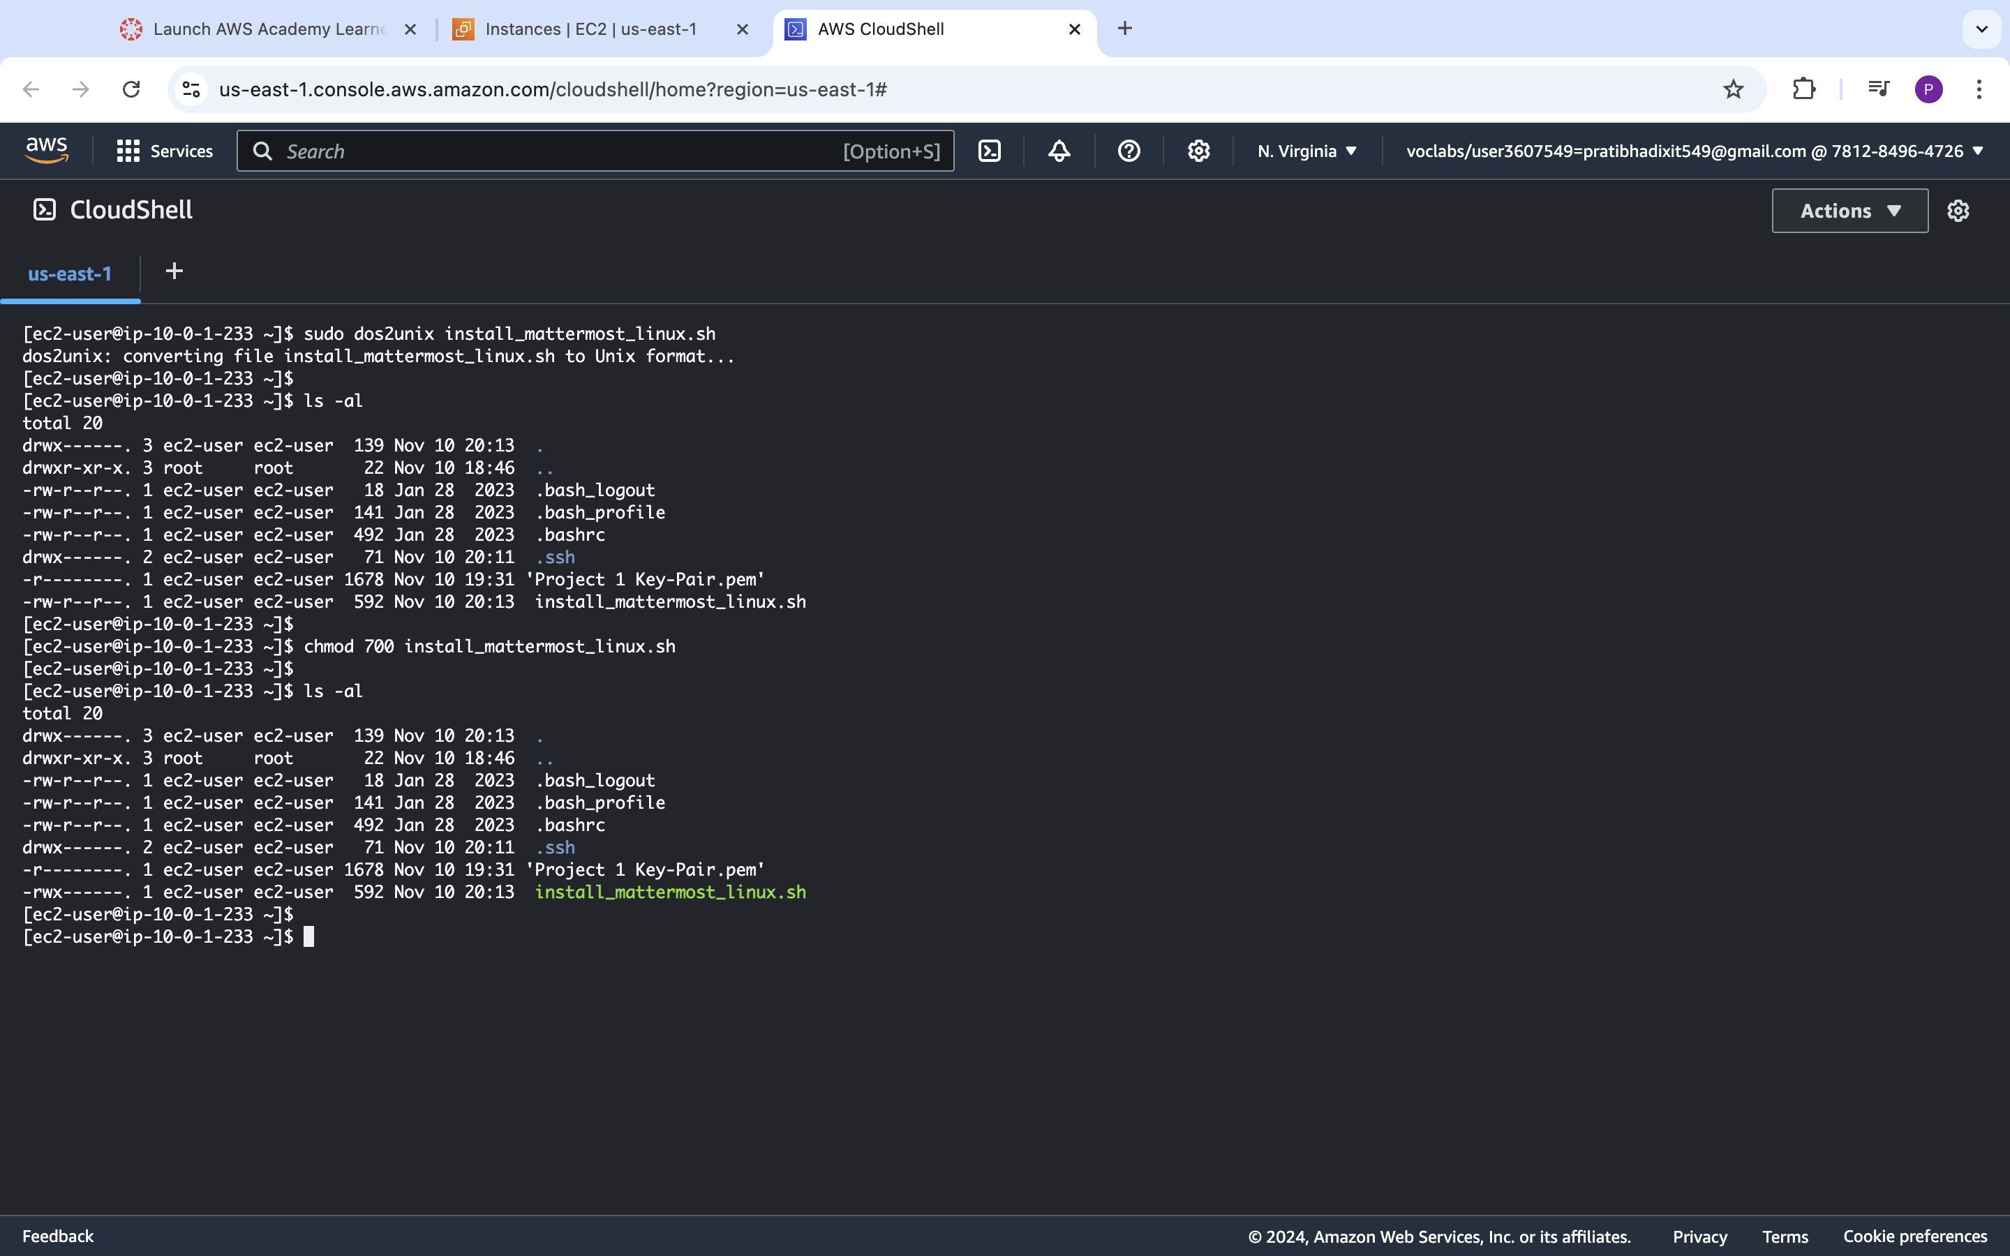

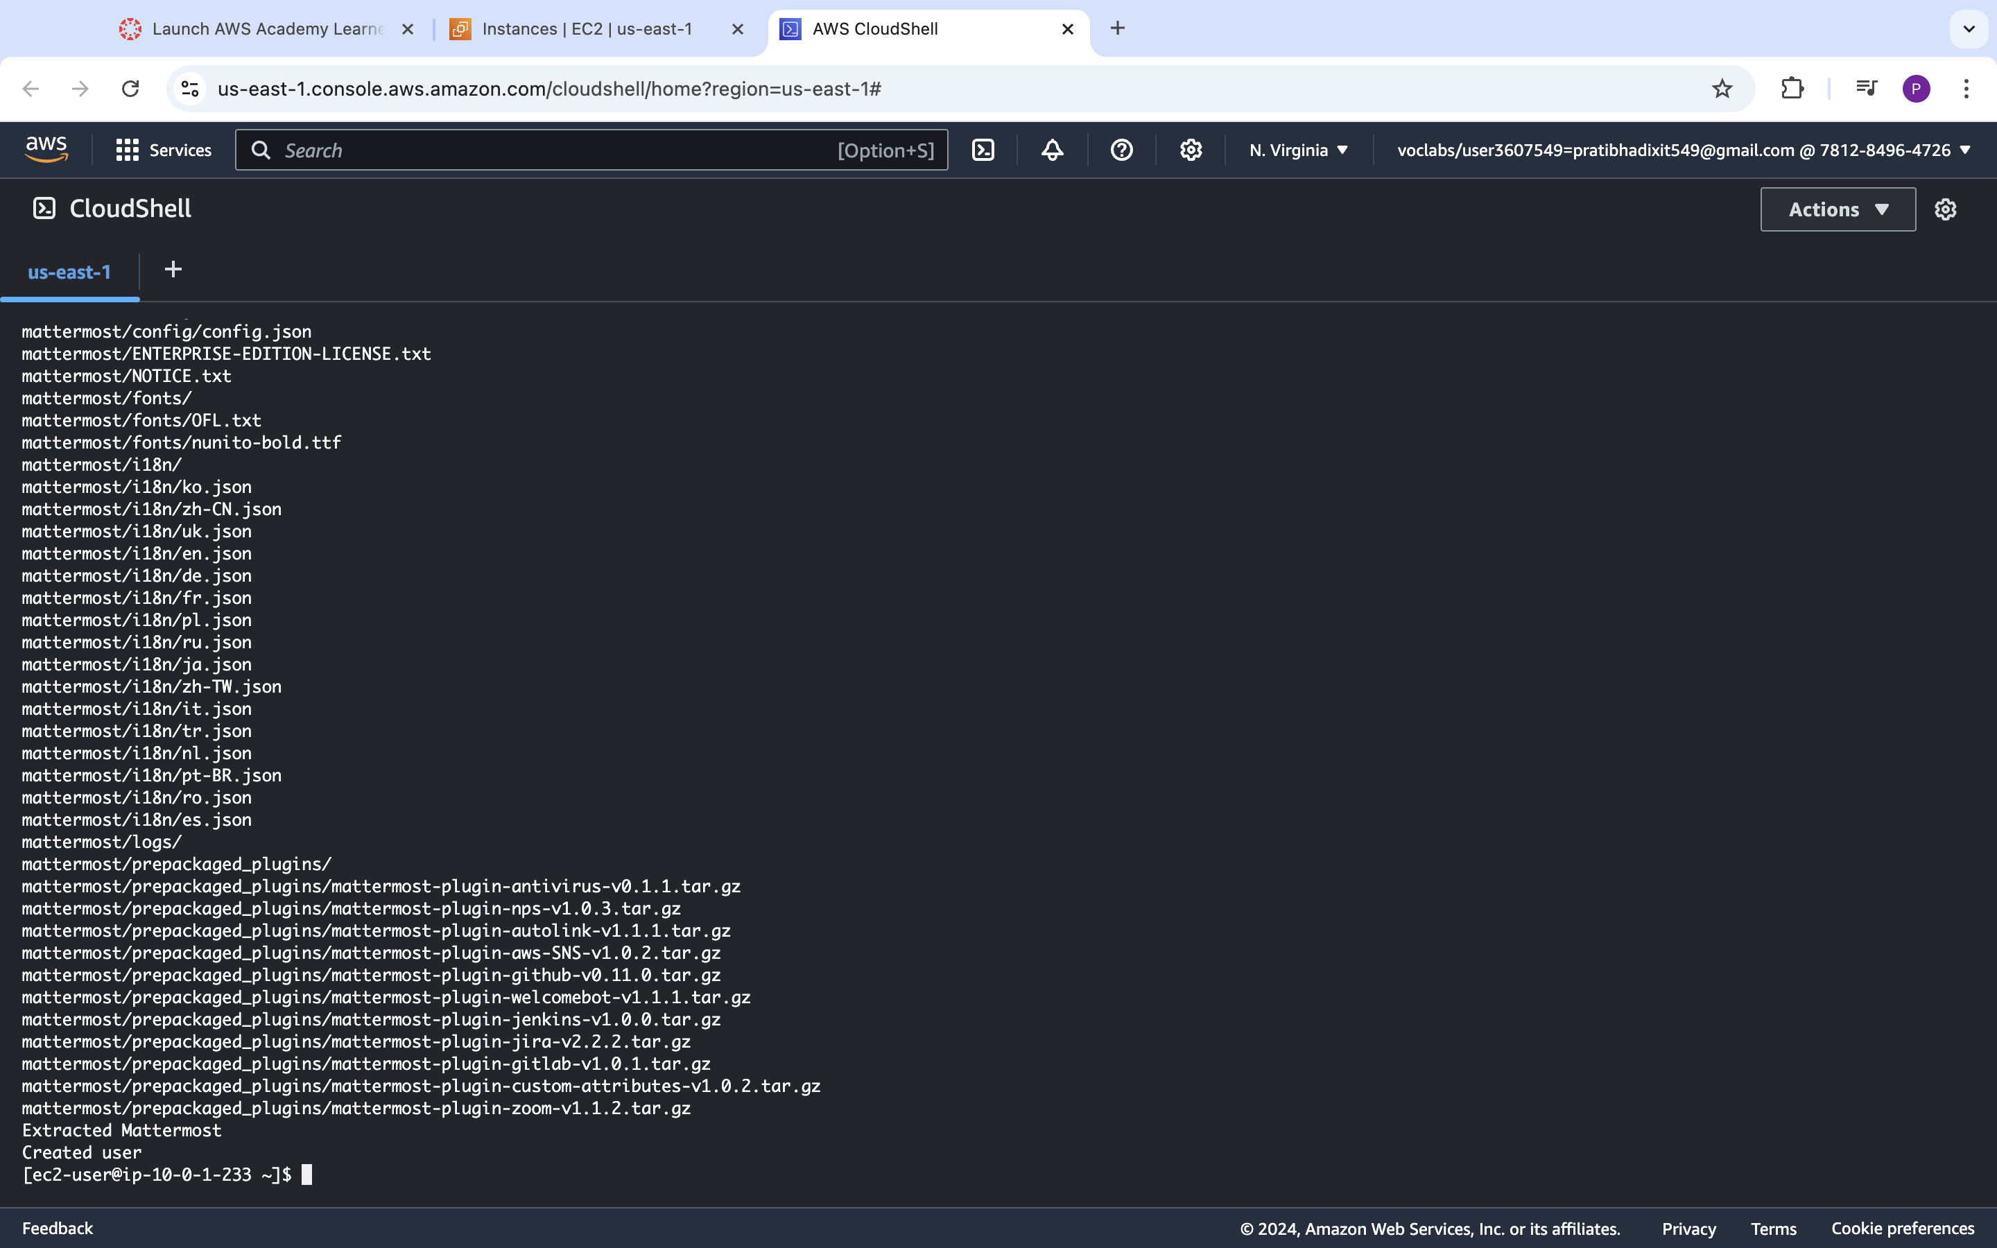

**<Insert screenshot b(2) here>**

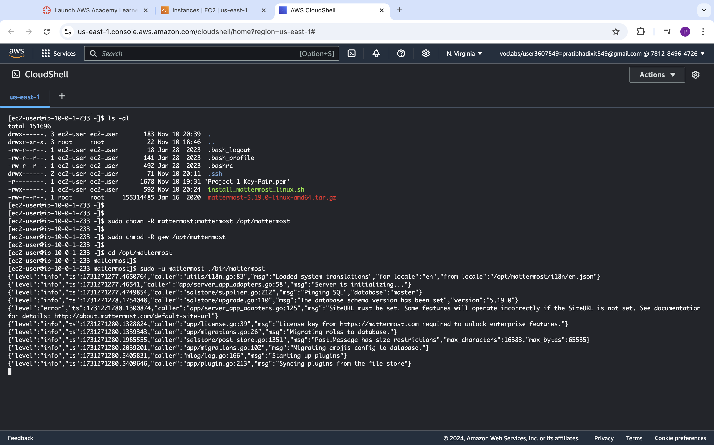

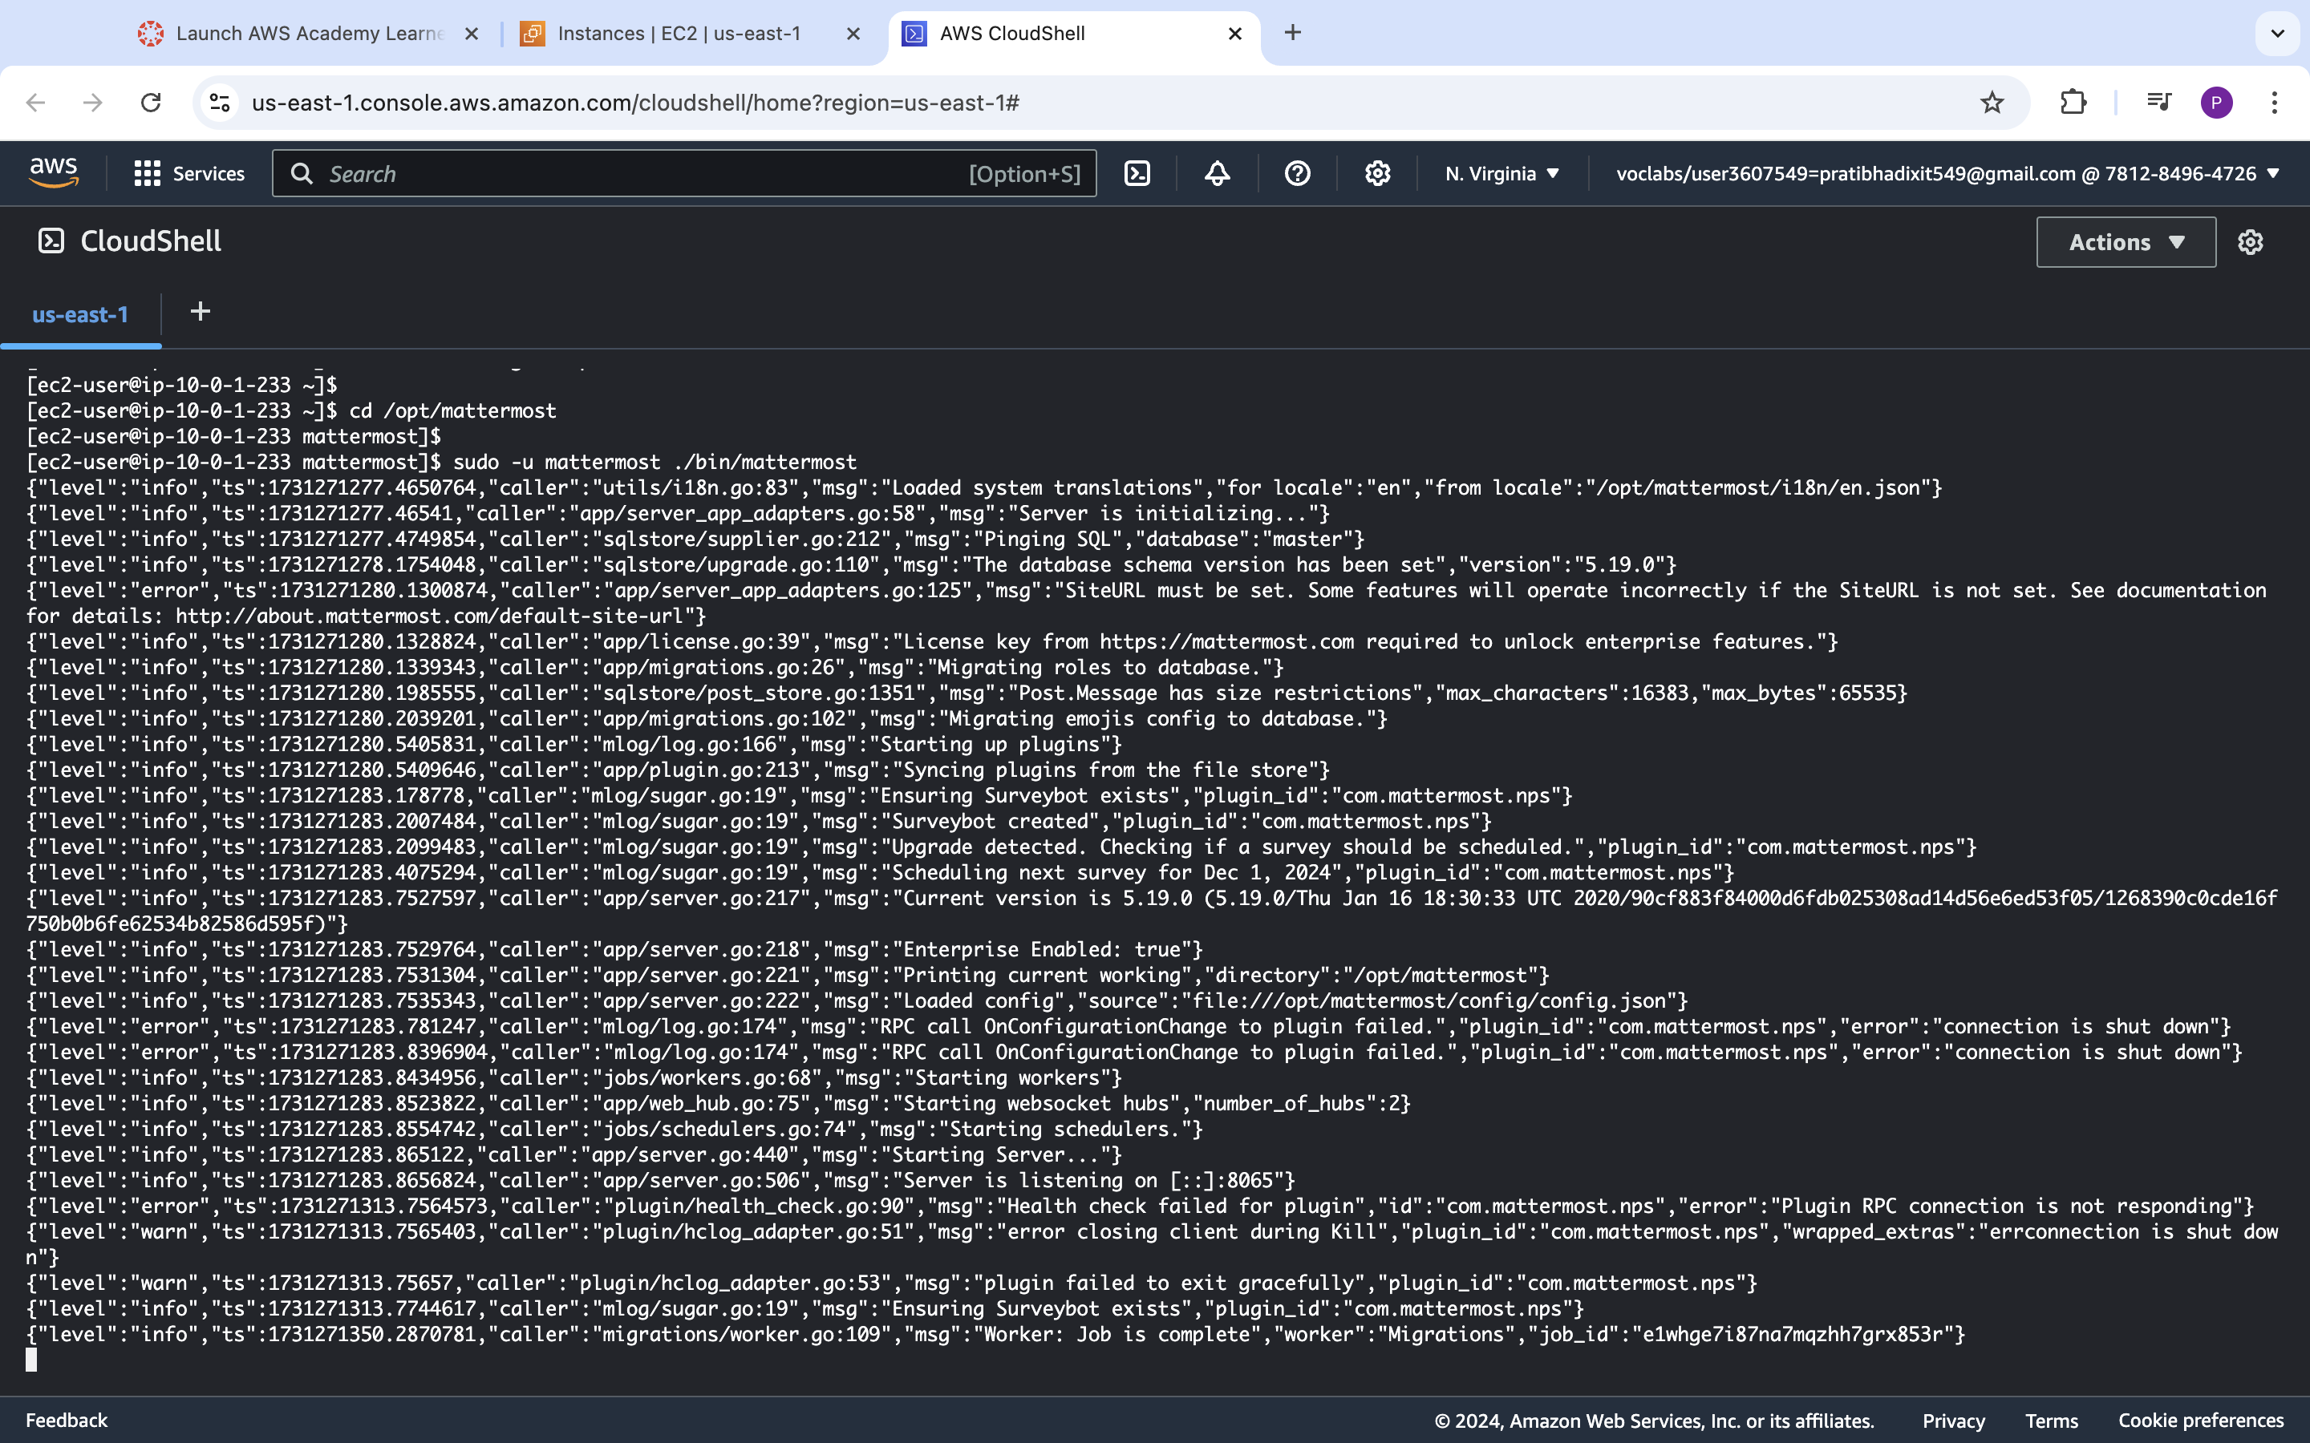

**<Insert screenshot b(3) here>**

